Archaeological Assessment
Bishop Lucey Park, Grand Parade, Cork

Avril Purcell MA MIAI
June 2021

______________________________________________________________________________________________________________________

Lane Purcell Archaeology,
64 Fr Mathew Road,
Turner’s Cross,
Cork

Job Ref. LPA1123

on behalf of
Hall McKnight,
B1.11 Portview,
310 Newtownards Road,
Belfast,
BT4 1HE

1 Introduction
1.1 Bishop Lucy Park (ITM 567246 571775) lies within the historic walled medieval city of Cork (RMP CO074-034001-) extending from Grand Parade on its east side to South Main Street on the west (Fig. 1). The north side of the park is overlooked by the former Church of Ireland Christ Church and its graveyard and the south side is overlooked by the backs of buildings fronting onto Tuckey St. Various archaeological excavations carried out over a number of years within the park have found medieval levels including remains of the Holy Trinity Chantry College (CO074-034010-) and the city’s defences (CO074-034002-). The former Christ Church stands on the site of the medieval parish church of the Holy Trinity (CO074-034009-) with which the Chantry College was associated. The graveyard (CO074-034008-) on its east side contains grave markers dating from the 17th century and Christ Church Lane runs along the northern perimeter of the park. South Main Street formed the southern half of the central spine of the medieval city. Grand Parade runs on the line of a medieval watercourse (outside and parallel to the city wall) which was finally culverted in the second half of the 18th century.

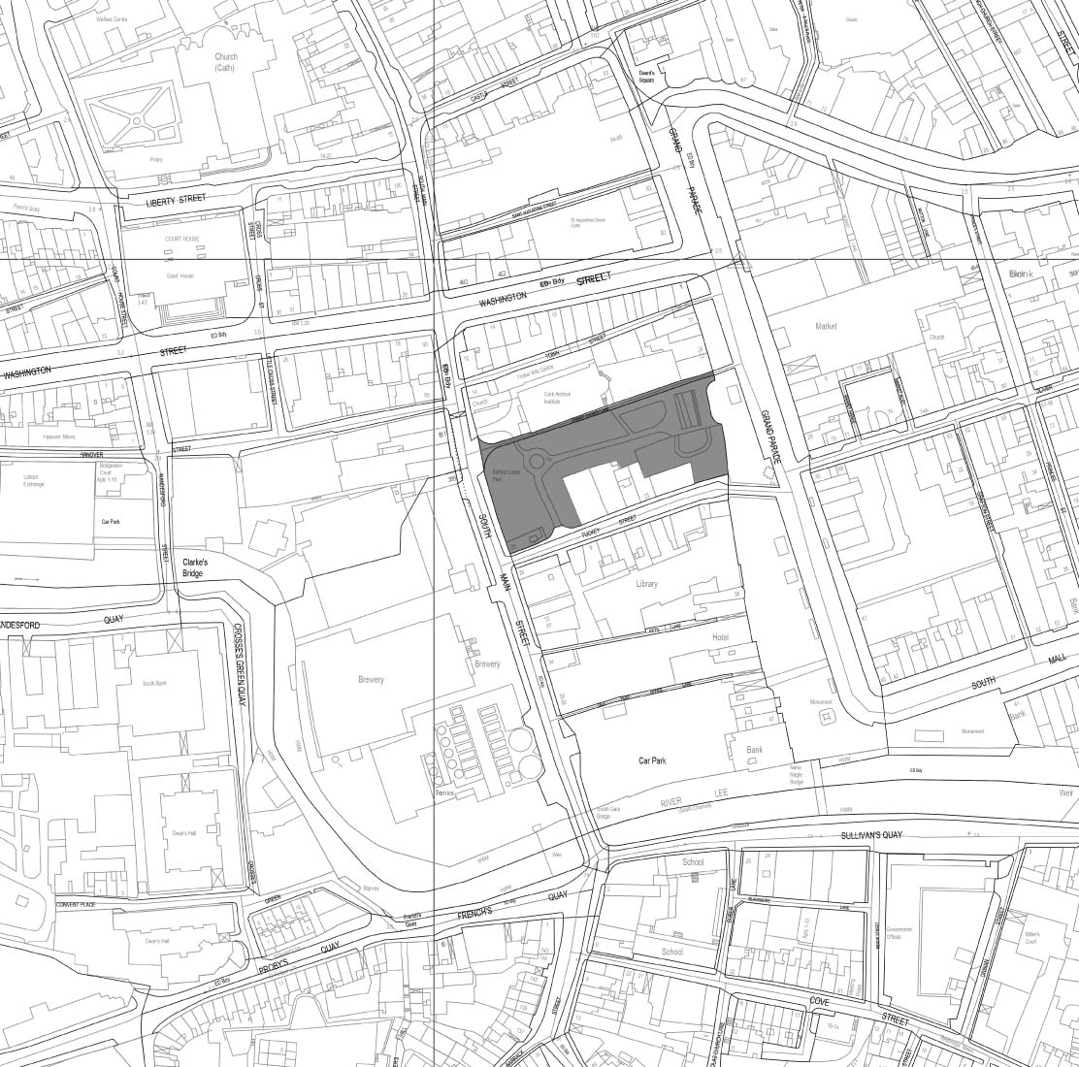
Figure 1: Extract from OSI map (1:2,500) showing Bishop Lucy Park shaded (Hall McKnight Architects)

1.2 The park incorporates open green space cut by pathways and at its eastern end a portion of the city wall remains exposed as a cultural heritage feature, following its excavation in 1984 (Fig. 2) (Hurley 1985). The park is entirely enclosed by low walls topped with railings and is accessed through a number of gates. Cork City Council, the owners, have approved a design by Hall McKnight Architects to redevelop and enhance the park as a focal point within the city centre. The design includes a proposal to expose an additional portion of the city wall, making it a central feature, effectively defining the eastern edge of the park and becoming a strong visible element of it. Lane Purcell Archaeology have been co-opted by Hall McKnight Architects as archaeological consultants for the project. All recommendations in this report have been made following discussions with Cork City Archaeologist, Ciara Brett.

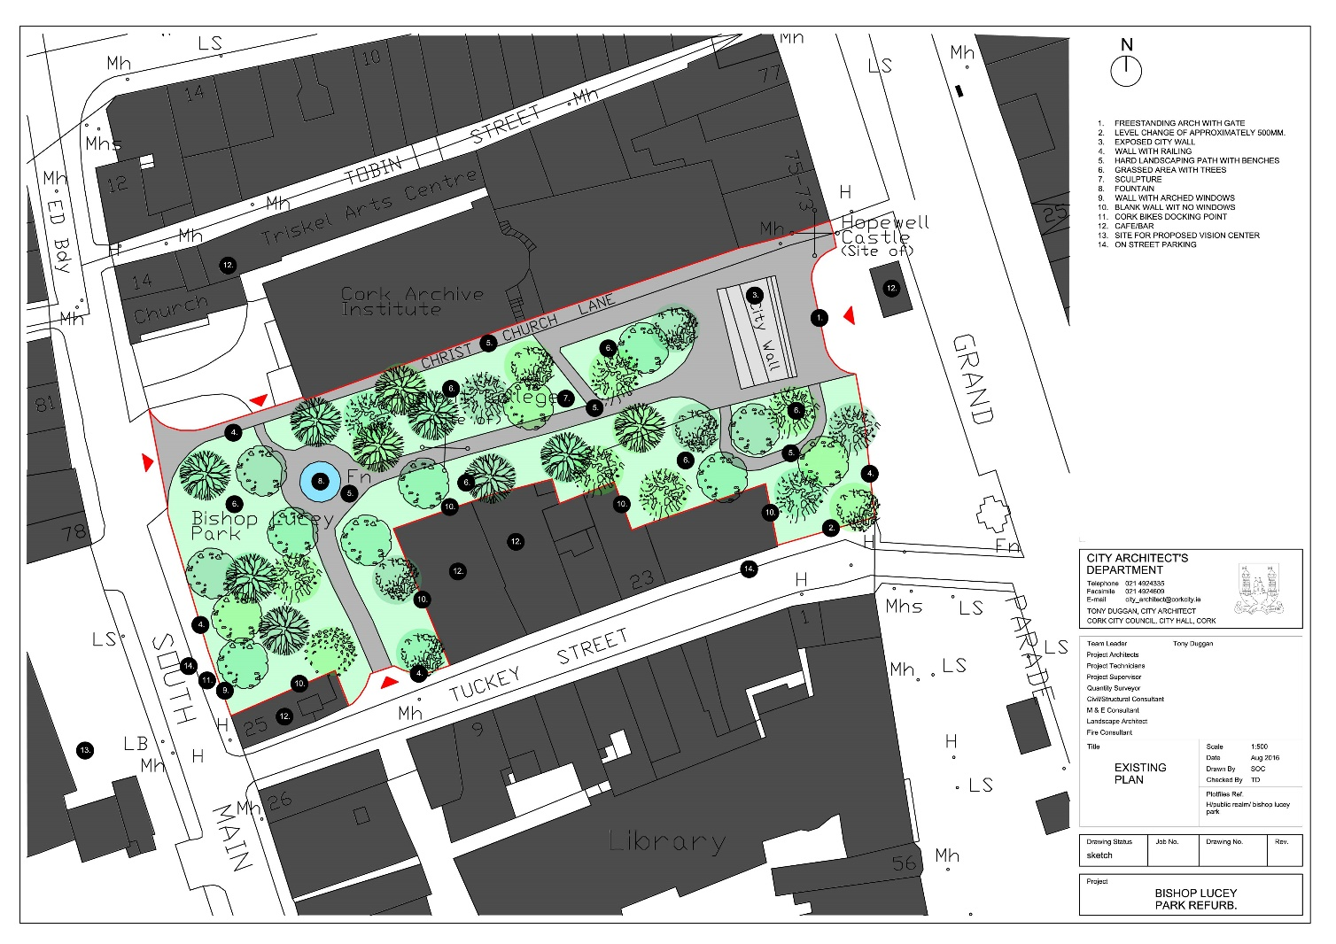
Figure 2: Existing layout of Bishop Lucy Park showing exposed portion of city wall (Cork City Council)

1.3 The planned redesign of the park has evolved to address archaeological and other constraints and alterations have been made to minimise the potential impact of ground works on underlying archaeological deposits. The proposed development incorporates a number of new structural elements some of which will require ground works to accommodate foundations (Fig. 3). A raised, hard-surfaced plinth will extend from the South Main Street eastwards across the park towards the city wall and the Grand Parade. The plinth will accommodate existing features of the park including the fountain at the west end and numerous trees as well as incorporating several new elements. A tower will be constructed at the southwestern corner of the plinth and a shelter at the northwestern corner close to the existing fountain. Both structures are likely to require some discrete piles or a raft foundation. A larger structure, the pavilion, will be constructed at the eastern end of the plinth overlooking the city wall and a bridge will be constructed to cross the wall immediately adjacent to and north of the pavilion. Piled foundations or possibly a raft foundation will be required to support the pavilion and bridge. The city wall itself will become a focal point of the park, and will be exposed from the southern side of Christ Church Lane for a length of approximately 26m to the south. Ground levels to the east and west of the city wall will be lowered to enhance the setting and visual amenity of the wall as well as providing limited access to it. Christ Church graveyard to the northeast will be illuminated and some lighting may be focused on the eastern gable of Christ Church to enhance its visual amenity.

1.4 Although a number of archaeological excavations have been undertaken in the park since the 1970s the entire area of the park has not been fully archaeologically resolved. These were the earliest urban excavations in the medieval city of Cork and informed the large number of commercially driven investigations that followed over the succeeding decades. They revealed the wealth of subsurface remains surviving within the core city centre area and are detailed below.

1.5 This report was compiled by Avril Purcell, Lane Purcell Archaeology, 64 Fr Mathew Road, Turner’s Cross, Cork on behalf of Hall McKnight, B1.11 Portview, 310 Newtownards Road, Belfast, BT4 1HE.

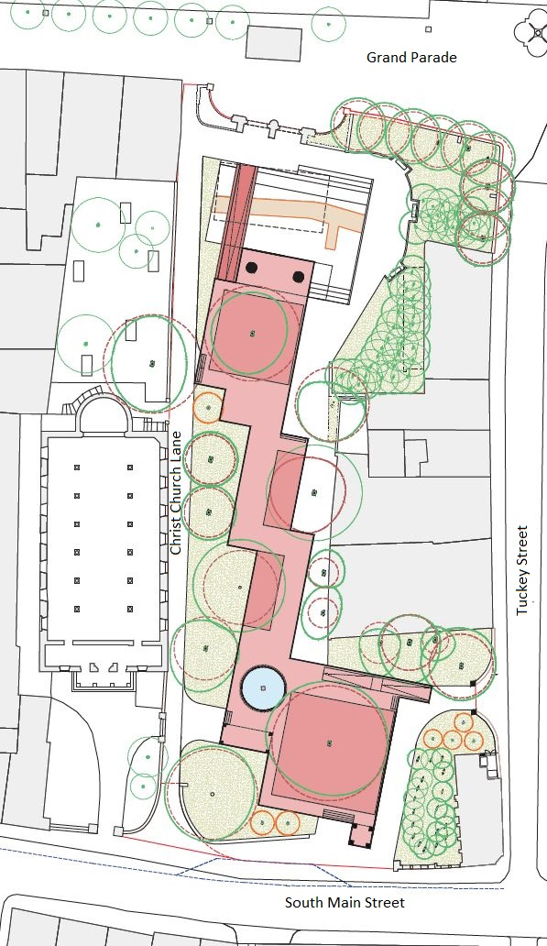
Figure 3: Layout of proposed scheme (after Hall McKnight Architects) (North at left of image)

2 Archaeological and Historic Background
2.1 The proposed development site lies inside the historic, walled, medieval city of Cork and within the Zone of Archaeological Potential for the historic city (CO074-034001-) as listed in the Record of Monuments Places (RMP) for Co Cork and in the Sites and Monuments Record (SMR) database of the Archaeological Survey of Ireland (Fig. 4). The RMP lists all archaeological monuments and places known to be of archaeological importance in the county and affords them statutory protection under the National Monuments Act 1930 to 2004 (1994 amendment). The SMR database is a working database of all known archaeological monuments in the state and is continually updated. The medieval city comprised a south and north island within the broad tidal estuary of the River Lee. Archaeological excavations have found that the first phase of urban development of the historic city was in the late 12th century and centred on the South Island in the area of the present South Main Street.

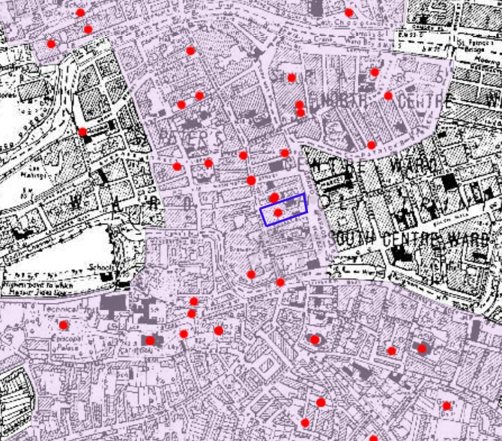
Figure 4: Extract from RMP map showing Zone of Archaeological Potential of historic city (shaded) with blue outline showing block between Tuckey St and Christ Church Lane including Bishop Lucy Park

2.2 The earliest beginnings of Cork City as an established settlement can be traced to the monastic foundation of St. Fin Barre, on high ground on the south bank of the river in the 6th/early 7th century AD (Gwynn and Hadcock 1970, 66). Historical references place a Viking settlement in Cork from 846, probably located on the south bank of the river opposite South Gate Bridge (CO074-034012-). Archaeological evidence has identified Hiberno-Norse activity by the second half of the 11th century on the southern end of Barrack Street on the south bank of the river (Lane and Sutton 2003, 12). Across the south channel of the river on the south end of the south island (City Car Park site) and within the muddy estuary, reclamation associated with the development of settlement plots, began at the end of the 11th century (Ní Loingsigh 2014, 40 and Cleary 2014, 266). Archaeological excavations on a number of sites on the south island have found that in the 12th century the cycle of a house plot comprised the construction of a post and wattle house followed by its occupation, demolition and rebuilding. This process was repeated over generations incorporating first wooden and then stone structures and thus the city developed and grew extending northwards along what is now the South Main Street and eventually onto North Main Street and the North Island. The settlement on the South Island was probably walled by the late 12th century and by the end of the 14th century the circuit extended around the North Island as well. There are numerous records of repairs being carried out on the walls up to the late 17th century. In the second half of the 17th century, with a growth in the overseas provisions trade, the economy of the city was growing rapidly and reclamation of the marshes to the east and west began. During the Siege of Cork by the Williamite forces in 1690, the city wall was breached, the suburbs burned and many of the city’s buildings destroyed (Bradley et al 1985, 15-26). After the Williamite victory a period of relative stability followed in Ireland and the need for walled defences around urban settlements lessened. The walls, in any case, were in poor repair after the siege and during the early 18th century much of the medieval town wall circuit was demolished facilitating the city’s expansion eastwards and westwards into the marshes where reclamation was underway. This demolition was generally only to ground level leaving much of the walls intact below the surface. According to Hurley (2005), Cork possesses the most intact circuit of subsurface walls of any Irish city. The medieval walls (CO074-034002-) enclosed a sub-rectangular area, approximately 654m N-S; c. 225m E-W. There were sixteen mural towers along the walls and at least two major gateways as well as a watergate. The key to the preservation of the city walls is Cork’s marshy location in the tidal estuary. The city’s residents were in a constant battle to raise their habitation level above the tidal floodwaters and so approximately 3 metres of introduced clay and dumped organic material was built up within the town between the 12th and 14th centuries, sealing the lower levels of the town walls in remarkably good condition (ibid).

Inside the walls the city itself ran along a central spine of higher ground, along which the Main Street was aligned with smaller streets and lanes running at right angles to it. These lanes were generally located between every second property and provided access to the rear of the long narrow burgage plots which extended from the main street as far as the city walls. The lanes would also have facilitated access to the city defences. Much of this layout survived the modernisation and expansion of the city as well as the culverting of its surrounding watercourses which first became open quays and then streets. This linear layout characterises the medieval core of the city and, combined with the survival of subsurface remains of the city wall, have ensured that the imprint of the medieval streetscape endures within the modern city.

2.3 The walls, or sections thereof, lie buried beneath the modern-day streets and buildings and have been identified during archaeological investigations at numerous locations since the 1970’s. Sections of the medieval wall have been recorded within Bishop Lucy Park (Hurley and Power 1981, Hurley 1985; Hurley 1989; Hurley 1990) and nearby at Kift’s Lane off Grand Parade (Hurley and Power 1981), at 81-83 Grand Parade (Wren 1995) and 40-48 South Main Street in Cork City Car Park (Sutton and Ní Liongsigh 2014, 31) where 30m of continuous wall was exposed. Further sections of the city wall have recently been identified at the Beamish and Crawford site on South Main Street (Hurley pers comm.). At City Car Park, the excavated remains were substantial with the wall constructed largely of sandstone with approximately 10% limestone (Ní Liongsigh 2014, 86). It had an inner and outer face and a rubble core. At 40-48 South Main Street it was between 1.36 and 1.45m wide and 4m high (ibid.) while in the park itself it was between 2.2m and 2.35m wide at the top and at its base (including its stepped footings) it was 4m wide (Hurley and Power 1981 & Hurley 1985, 69).

2.4 There are no cartographic depictions of the early walled town from the 12th century or its expansion northwards in the 14th century. The later medieval town is depicted on historic maps from the late 16th century and its development can be traced on cartographic sources from this time, as it developed from a defensive walled city, to the larger, expanding city of the late 19th century. One of the first cartographic representations of the city of Cork is the Pacata Hibernia (1585) (Fig. 5). This map depicts the walled city on the River Lee, spanning two islands (north and south) and joined by a bridge. The walls are interspersed with numerous round mural towers and tidal marshland occupies the areas to the east and west of the city. Bridges at the northern and southern extremity connect the city to the shore. Boats are depicted navigating the river channels enclosing the city while suburban development outside the city walls is evident by the depiction of Ye L. Barris Castell (Shandon Castle; CO074-032) to the north and the Cathedral Church of old Corke (St. Finbarr’s Cathedral; CO074-038002-) to the south. The round mural tower depicted to the east of Christ Church is probably Hopewell Castle, the remains of which may have been exposed during works in the mid 1980s but these were unfortunately destroyed before an assessment was undertaken (Hurley 1995, 65).

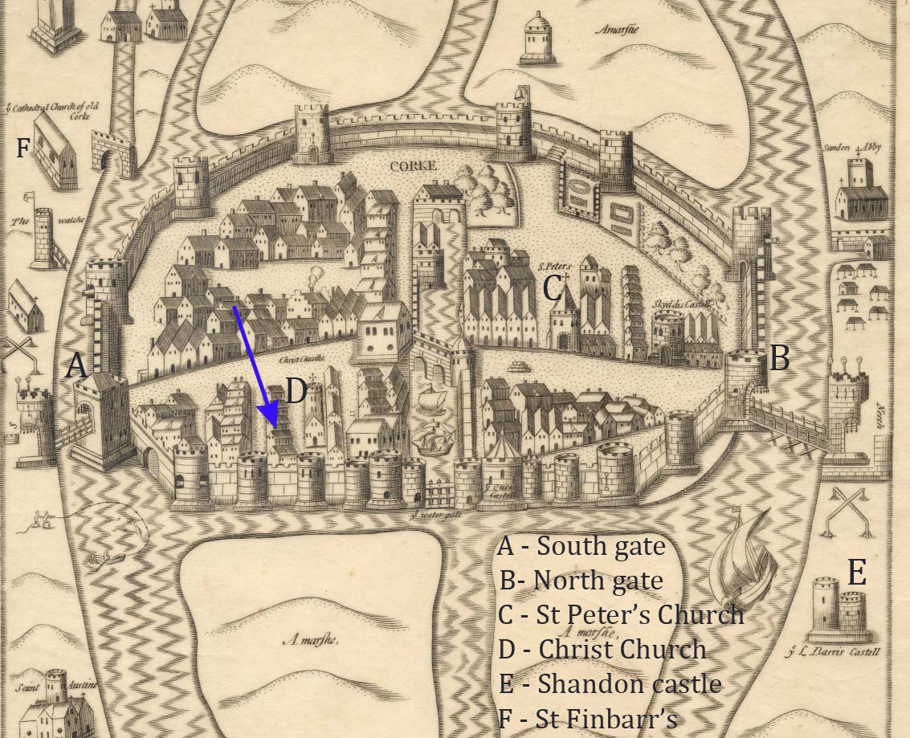
Figure 5: Extract from Pacata Hibernia (1585-1600) with arrow showing the approximate location of the park

2.5 The city remained a defensive urban settlement until its wall was breeched and it fell, after a siege by the Williamite forces in 1690. Its defensive nature was not re-established after this and instead it began a period of expansion outside the walls into the adjoining marshes. The wall was finally completely removed and the waterways outside it first became open quays and later were culverted. The modern streets developed along the line of these culverts. By the mid 18th century this process was well underway and Rocques map of 1759 shows the open watercourse to the southeast of the medieval city (along what is now Grand Parade) named Post Office Quay, extending from the South Channel of the Lee and becoming Tuckeys Quay as it continues north (Fig. 6). The Post Office Quay end of the watercourse is quite wide and it narrows as it extends north from a bridge at Tuckeys Lane/Georges Street to Tuckeys Quay. The area of the park is depicted as a built-up area with Christ Church Lane to the north and Tuckeys Lane to the south. An unnamed lane runs for a short distance into the northern half of the park from South Main Street. The narrow thoroughfares of the medieval city are in strong contrast to the wider streets to the east and west in the reclaimed ground into which the city is expanding. The constraints of the medieval city’s walls have been removed and its expansion is progressing but its medieval layout of narrow lanes perpendicular to the Main Street remains clearly apparent within its original core.
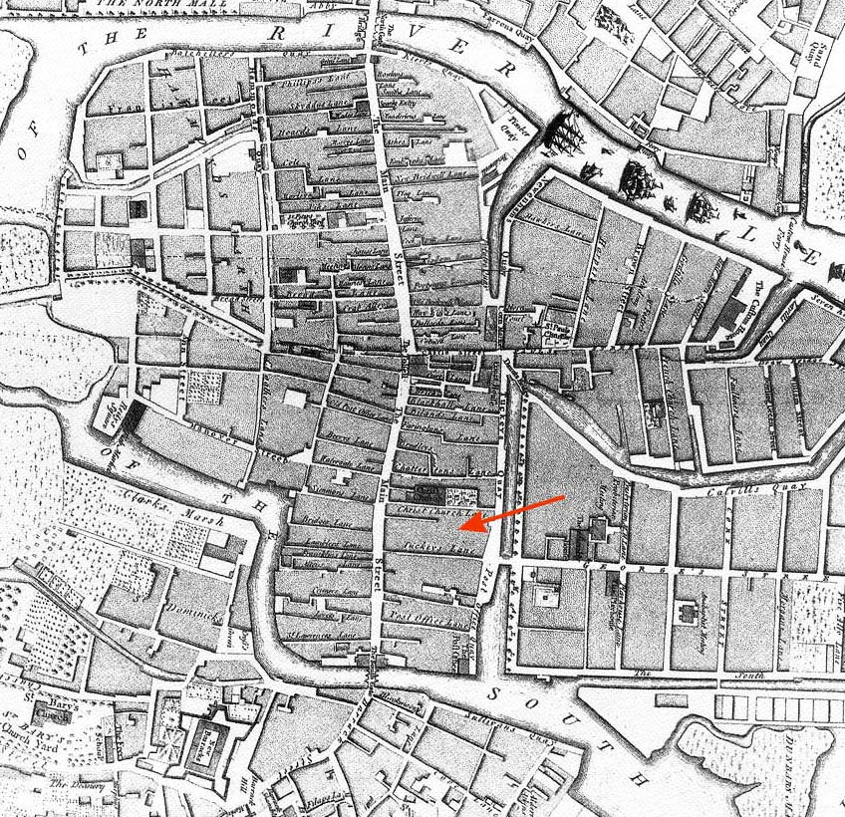
Figure 6: Rocques map of 1759, arrow shows location of Bishop Lucy Park

2.6 By the start of the 19th century the park is shown as a built-up area on Beaufords map of 1801 (Fig. 7). The wide boulevard that is Grand Parade has been laid out to the east completely concealing the watercourse underneath. Tuckeys Lane has become Tuckey Street and appears to have been widened accordingly. Christ Church Lane appears unchanged.

2.7 By the end of the 19th century Ordnance Survey maps (Fig. 8) depict the block in which the park is located as a densely packed modern urban streetscape, with continuous buildings fronting the Grand Parade, Tuckey Street, South Main Street and most of Christ Church Lane, where there is a break in the building line to accommodate a free standing ‘School and Alms House’ opposite the graveyard to Christ Church. The site of an ‘ancient college’ is shown to its west and the site of Hopewell Castle is shown at the junction of Christ Church Lane and Grand Parade to its east.

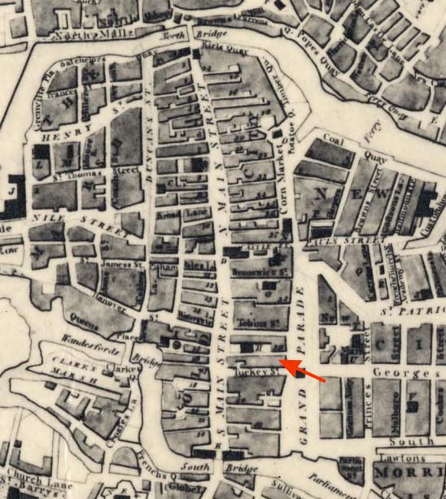
Figure 7: Beaufords map of 1801, arrow shows location of Bishop Lucy Park
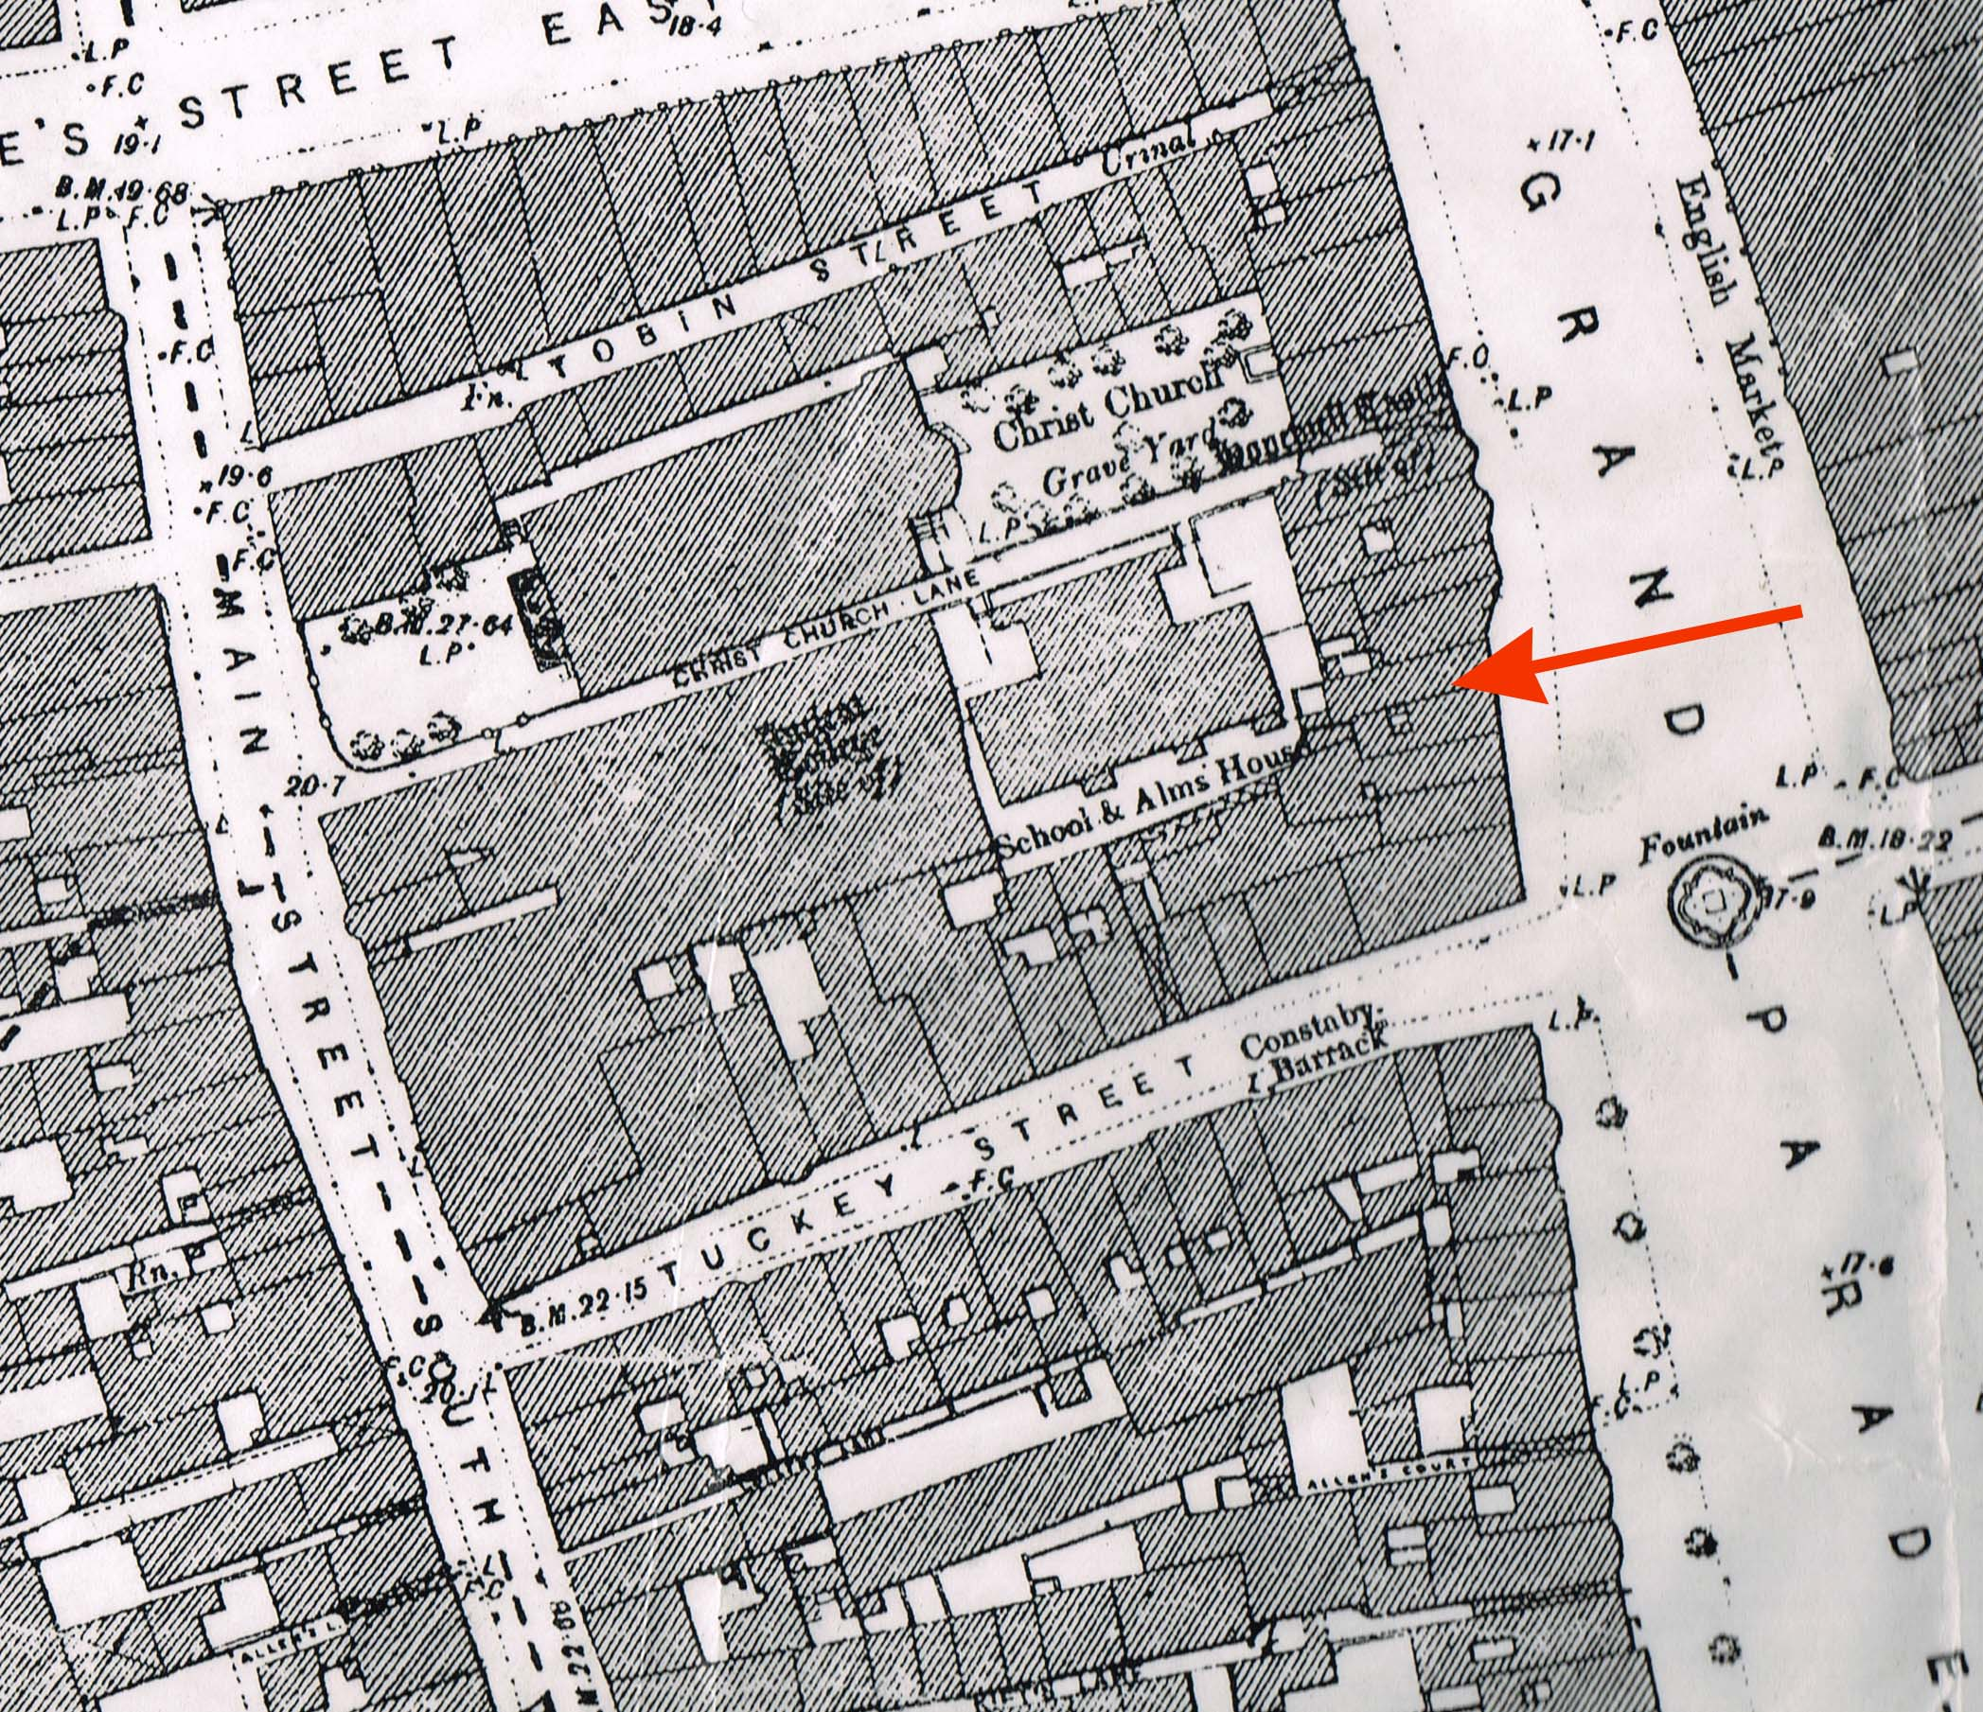
Figure 8: OSI map (1895) five feet to one statute mile with arrow showing location of Bishop Lucy Park

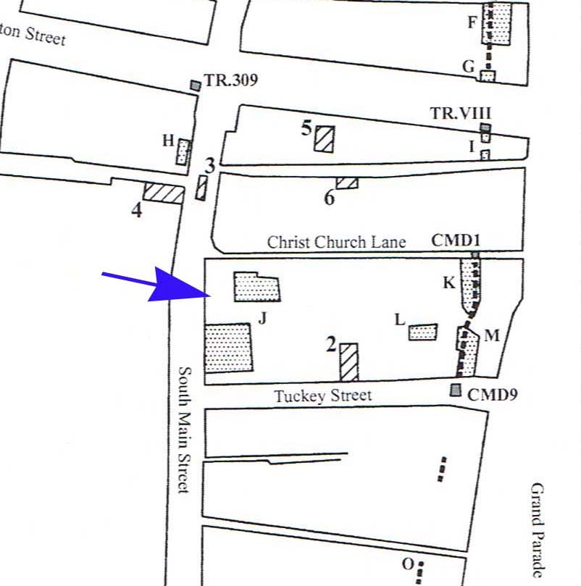
2.8 Since the 1970s five phases of archaeological excavations have been undertaken within the block that comprises the Bishop Lucy Park (Fig. 9). The earliest of these, in the mid 1970s, demonstrated the substantial levels of preservation within the medieval core and paved the way for further investigations in the following decades to reveal how settlement developed in the medieval city.

Figure 9: Areas excavated within block (after Cleary and Hurley 2003)
J Christ Church, Trenches C & H (1975-7)
K Grand Parade (1984)
L Grand Parade II (1985)
M Medieval town wall of Cork (1981)
2 Tuckey Street (1997)

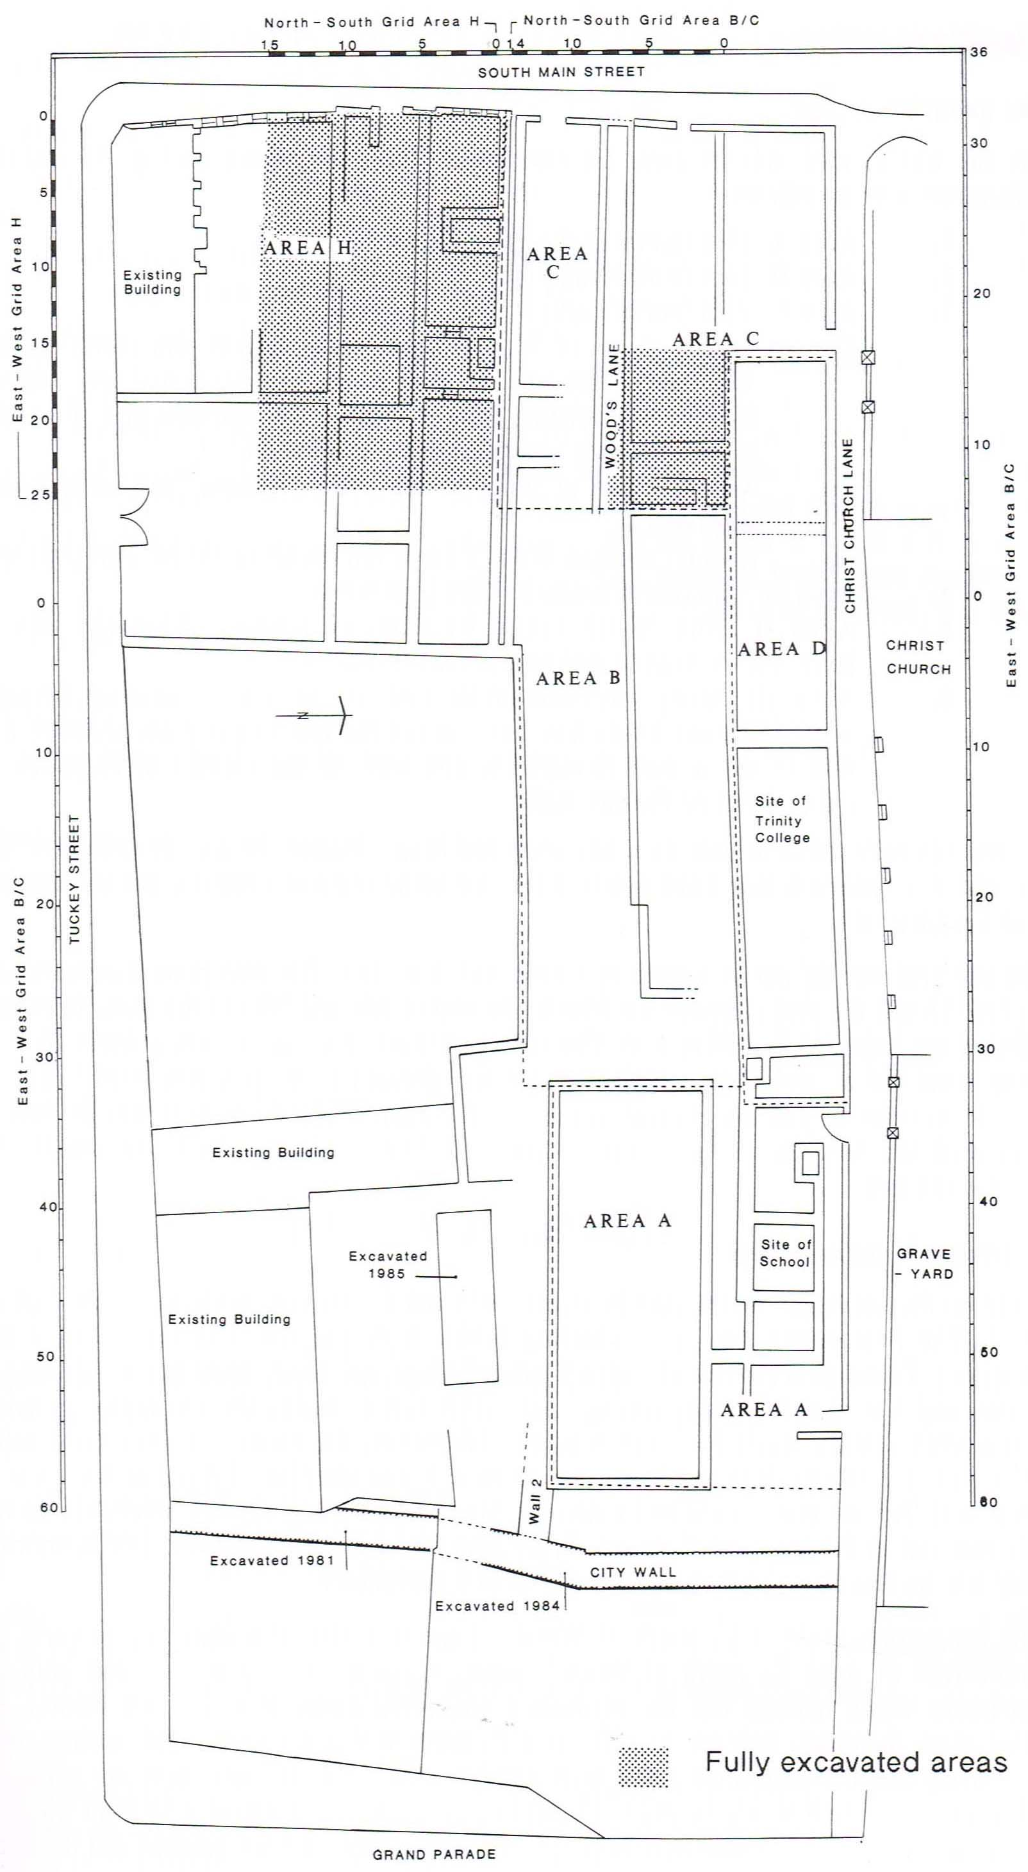
2.9 The earliest archaeological investigation within the park was carried out in 1975 by Dermot Twohig and continued intermittently over two and a half years. The excavation results were published posthumously two decades later (Cleary 1997). Brief resumes of the excavation seasons in 1975 and 1976 are published in the Excavations Bulletins (www.excavations.ie). The initial area of excavation encompassed most of what is now Bishop Lucy Park extending from Tuckey Street at the south to Christ Church Lane at the north (up to 42m wide) and east from South Main Street for approximately 96m. All of this area lay to the west of the line of the city wall. The objectives of the excavation in 1975 (Twohig 1975) were to identify (a) the remains of Christ Church College, (b) the medieval and post medieval street front and (c) the medieval wall and Hopewell Castle. Over the course of the excavation, the remains of Christ Church College were found, however, the medieval and post medieval street front was not identified nor were the medieval walls or Hopewell Castle. The entire area of the proposed excavation was almost 1 acre and only a small area was excavated to medieval levels. A plan of the site (Fig. 10) shows the walls exposed at the early stages of the excavation, including the walls of Trinity College, Christ Church and the later school which stood to its east. Figure 10: Areas subject to archaeological excavation 1975-7 (Cleary 1997, 2)
The college stood on the north side of the site and the walls are described as being ‘fragmentary ...measuring about 20m by 8m’ (ibid.). In 1976 Twohig reported that the college walls were sitting on piled timber foundations and that no window or door fragments were found. Excavation of medieval layers towards the South Main Street was curtailed by previous disturbance, however, an area to the rear of the street front yielded valuable information on life in the city in the 12th and 13th centuries (Fig. 9 Area J and Fig. 10). According to Cleary (ibid.) a trench was opened at the Grand Parade end of the park (Fig. 10, Area A) to the west of and inside the city wall. Unfortunately, the information on the excavation of this trench appears to have been lost (Cleary, ibid). It seems likely that if the wall was found in this trench Twohig would have mentioned it in his resumes. Sheila Lane, who worked on this excavation, has no recollection of the wall being found (pers comm.). The trenches excavated to medieval levels are referred to as Trenches C and H (Fig. 10). Other smaller pockets of medieval deposits were revealed in three areas in Area B, towards the centre of the excavation area but the excavation here appears to have been incomplete.

Trench C was located towards the northwestern end of the site approximately 17m east of the South Main Street street-front and measured approximately 10/11m E-W by 8m N-S (Cleary 1997, 26). The trench was divided E-W by the medieval Wood’s Lane and only the section to the north of Wood’s Lane was excavated to medieval levels (measuring 6m N-S by 10m E-W). Structural remains including post and wattle and sill beam houses were found in this area along with shell middens, drains and pathways and contemporary artefactual remains. Trench H was located south of Trench C and extended east from the South Main Street for approximately 13m, it was approximately 8m wide (N-S). The northwestern end of the trench and a 4m wide strip which extended from the street-front east across the trench were excavated to medieval levels. A post and wattle house and a possible second similar structure were uncovered as well as several sill beam houses from the mid to late 13th century and 14th centuries. Numerous boundary features, a pathway, trackway and pits (some stave lined), a cess pit and a possible metal working area were all revealed and excavated in this trench. Area B was located to the east of Area C, i.e. behind the street-fronting properties of South Main Street and towards the centre of the site. The cobbled surface of Woods Lane may have been exposed as well as randomly placed stakes and deposits containing Saintonge pottery. No further details are provided (Cleary, ibid.).

2.10 In the early 1980s two trenches were excavated in the southeast corner of the park adjacent to the Masonic Hall which opens onto Tuckey Street (Hurley and Power 1981, 1-20) (Figs. 9 Area M, Figs. 11a and b). Trench 1 (17m N-S by 7m E-W) was opened across the city wall and along its outer (eastern) face and a much smaller trench (7m N-S by 3m E-W), Trench 2, was opened inside the city wall.

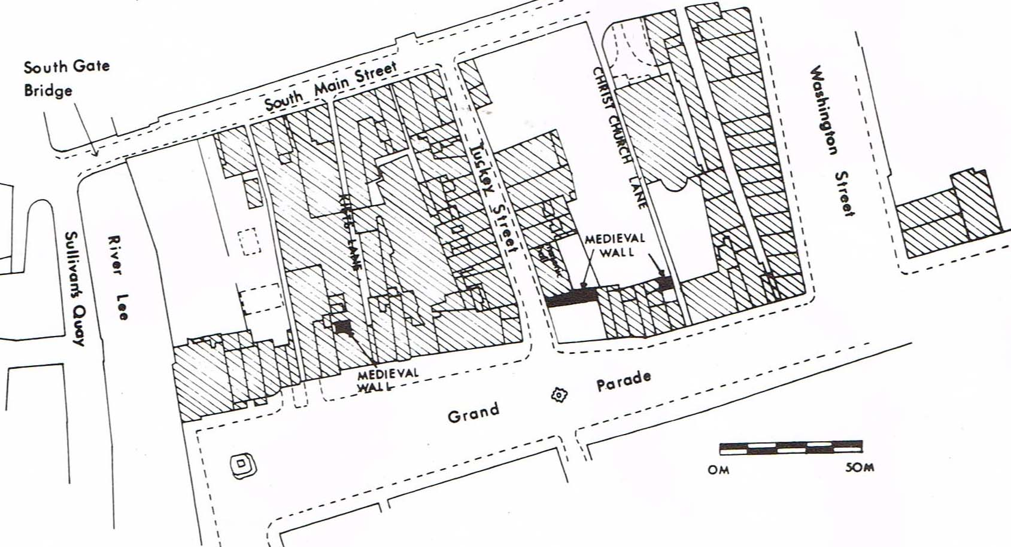
Figure 11a: Location of trenches excavated in 1981 (Hurley and Power 1981)

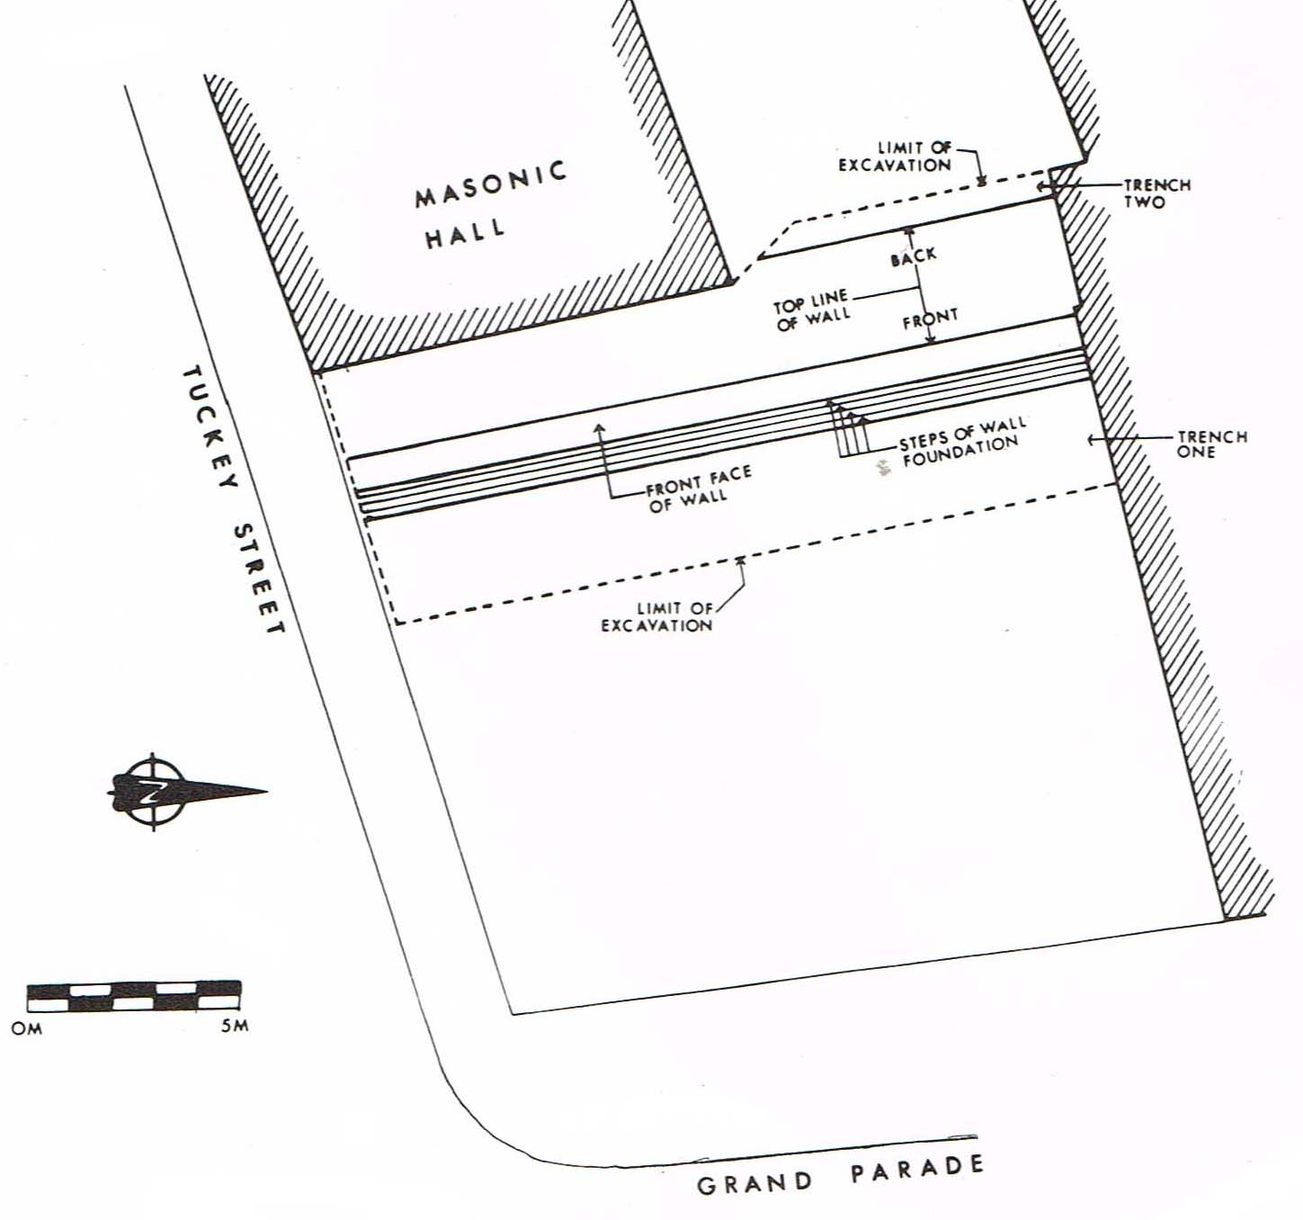
The primary feature exposed was the city wall which measured 2m in height, 2.35m wide at the top and 4m at the base, including the footings. The wall was built on a bed of brushwood and moss laid on the river muds which were quite thin with extensive gravel layers below. Five distinct layers were revealed outside the wall; the upper three were earth, stone and gravel which raised the ground level to approximately 1m above the water table. Layer 4 was a black organic layer containing post medieval artefacts and level 5 contained high quantities of limestone rubble and mostly 13th century artefacts. The former associated with the wall’s construction and the latter probably material dumped outside the wall when it was built. Inside the wall the stratigraphy was different comprising mostly post medieval material with a sealed 13th century occupation level (Layer 13) at the bottom of which a wattle wall was found. The excavators speculated this was associated with a house or property boundary. This report highlights two other locations of the city wall close by (Fig. 11a); one at the northeast corner of Bishop Lucey Park and the other a short distance to the south within a building close to Kifts Lane. While the report includes a short account of the section of city wall near Kifts Lane, there is no reference made to the other section of wall. It can only be assumed that the wall was seen here by the excavators themselves.
Figure 11b: City wall as revealed in 1981 Trenches 1 and 2 during excavation (Hurley and Power 1981)

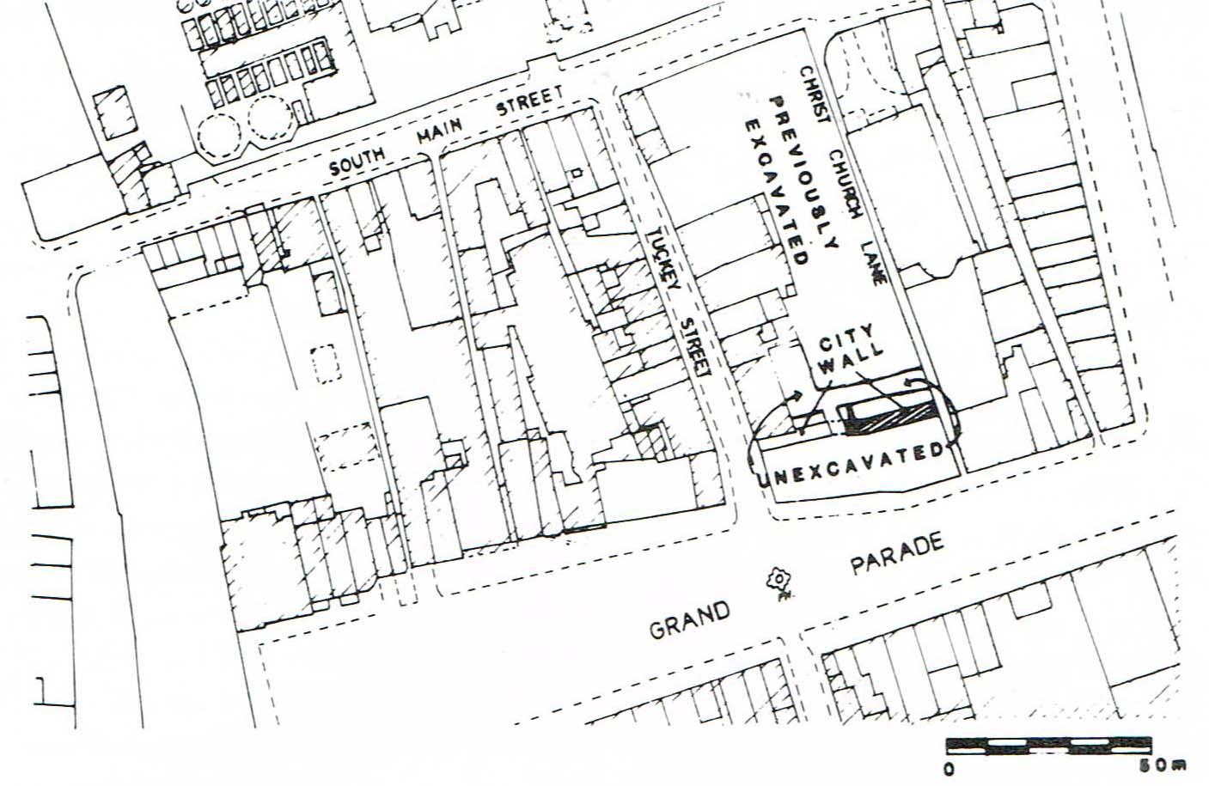
2.11 In 1984 that portion of the city wall which is now visible at the eastern end of the park was excavated (Hurley 1985, 65-90) (Fig. 9 Area K, Figs. 12a and b). The excavation was initiated by Cork Corporation with a view to presenting the city wall as an amenity within the park. Unfortunately, during the course of the initial investigations unsupervised works outside the city wall to the north led to the demolition of a substantial stone structure which Hurley (ibid.) speculated may have been the base of Hopewell Castle. The castle is shown in this location on historic maps of the city, however given the circumstances of its demolition the nature of the structure remains unknown.
Figure 12a: Location of trench excavated in 1984 at northeast of park (shaded)
and trench excavated in 1981 also denoted to the south (Hurley 1985)
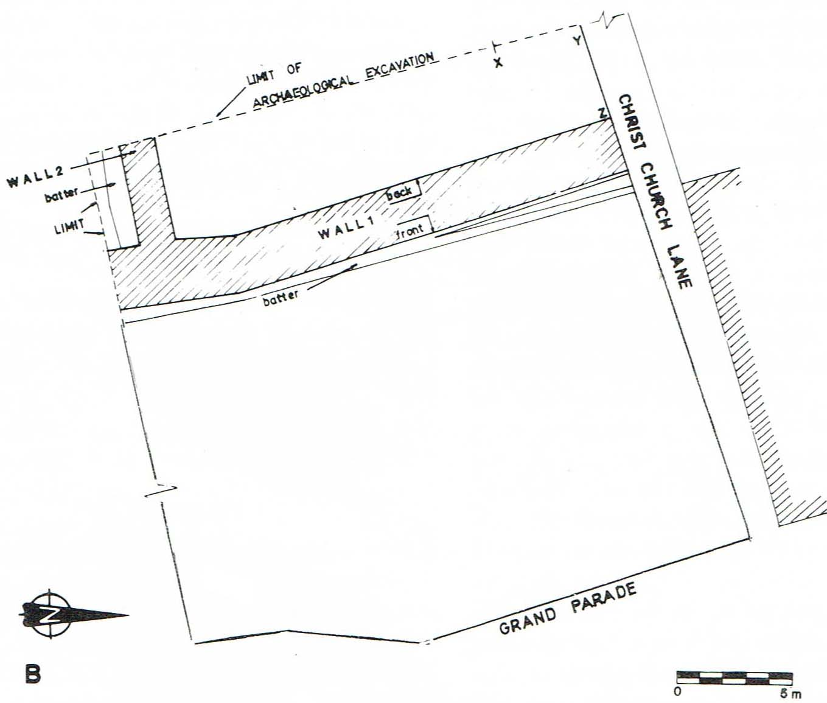
During the excavation a trench 5m wide (E-W) by 22m long (N-S) was excavated exposing the city wall (Wall 1) and an earlier wall (Wall 2) close to its southern edge. The city wall was exposed for 22m from the southern edge of Christchurch Lane and was on average 2.2m wide. A substantial joint in the wall was noted 5.5m from the southern edge of the excavation indicating it was built in at least two stages. The inner face of the wall north of the joint was significantly less substantial than the inner face south of the joint, however, the outer face of both was built to present as a uniform defensive feature similar to the wall excavated by Hurley and Power (1981) in the adjacent trench to the south in the early 80s (Hurley 1985). Figure 12b: Location of Walls 1 (city wall) and 2 revealed in 1984 trench (Hurley 1985)

Constant flooding limited the scope of the excavation and neither the city wall nor Wall 2 were excavated in their entirety. The nature and extent of the latter was not determined, although it was speculated by the excavator that it may have formed part of a dock. It was noted that the deposits to the north and south of Wall 2 varied significantly. The deposits to the south of this wall comprised occupation layers from the mid 13th to the 19th century including floor levels sitting above clay layers which were deliberately introduced to raise the ground level prior to occupation at the earliest level. To the north of Wall 2 such medieval occupation layers were not present and estuarine clay was found at a higher level (1.5m higher) leading the excavator to speculate this area was outside the city until possibly the 16th or 17th century and that Wall 2 formed the southern wall of a dock. This would place the rest of the 13th century dock wall, if present, to the west of the area excavated. This hypothesis is further supported as the northern face of Wall 2 was not battered but instead the southern face was. A batter on the northern elevation would hinder possible boats mooring against this wall if it was in fact a dock.

Evidence was also found of human remains which were found in a pit cut into 19th century rubble, probably re-deposited from the cemetery associated with Christ Church. The bones were of at least 23 individuals and were described as the ‘more resilient longbones’ (Ó Donnabháin in Hurley 1985) probably derived from graveyard clearance. Their weathered condition was noted suggesting they may have been exposed on the surface for a time prior to reburial.

2.12 In 1985 further excavation was undertaken in the park and an area 11.5m E-W by 3.5m N-S was excavated to a maximum depth of 3.6m (Fig. 9 Area L and Fig. 13) (Hurley 1989 27-45 and 1990, 64-87). The trench was opened towards the centre of the eastern end of the park. Five archaeological levels were identified following the removal of the overlying 17th to 19th century walls and rubble layers. The levels are numbered 1-5 with level 5 being the earliest material. Level 1 was an organic mixed garden soil probably dating from the mid 14th to mid 17th century and contained pottery dating from the early 13th century to the mid 17th. The material appeared to have been frequently dug for garden cultivation. A large pit was found in the centre of the trench which was packed with human bones. This was similar to a pit found during the 1984 excavation of the city wall a short distance to the north (Hurley 1985) and was associated with graveyard clearance or disturbance in recent times, possibly at the nearby Christ Church burial ground.
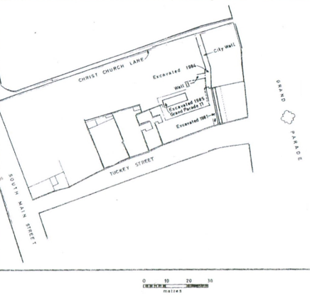
Levels 2 and 3 each produced evidence for remains of a house, the former probably dating from the end of the 13th century to the first half of the 14th century and the latter probably dating to the last quarter of the 13th century. Below this, in Level 4, domestic structures were not encountered instead extensive layers of dumped material were present. The layers were 1m deeper at the eastern end of the trench to accommodate the natural slope from the higher ground at the west to the waterway outside of the wall along the route of the Grand Parade at the east. This deposition was presumably a deliberate act to raise the ground level especially at the eastern end of the site which was likely prone to flooding. The nature of the dumping suggested material, probably domestic in origin, was dumped in small quantities over a short amount of time. Large timber beams and planks appeared to have been thrown in to form a ramp to facilitate dumping material into the wetter ground at the east to extend the reclamation.

The earliest level, Level 5 revealed a timber platform, random timbers and a brushwood floor partially covering the estuarine clay which was cresting at the western side of the trench. In the lower ground at the east two collapsed wattle fences and organic fills were found. A pit in this area was probably the earliest feature on the site dating to the middle of the 13th century.

Figure 13: Location of trench excavated 1985 and line of city wall excavated in 1981 and 1984 (Hurley 1989)

2.13 In 1997 excavation was carried out at the southern end of the block within a building fronting Tuckey Street approximately half way between the South Main Street and the line of the city wall (Fig. 14) (O’Donnell 2003). Evidence of a deliberate reclamation process was found in the earliest levels on the site dating to the early 12th century. Layers of clays were deliberately introduced into the site to raise the ground level. At the base of the clay layers a timber fence dating to1115-1122 AD was built running east west across the site possibly dividing it into two properties which would have fronted the Main Street to the west. Over the following 20 to 30 years the clays were introduced raising the ground level by between 1.15m and 1.3m to make it suitable for occupation. This reclamation process has been identified within the south island of the city on a number of excavations.

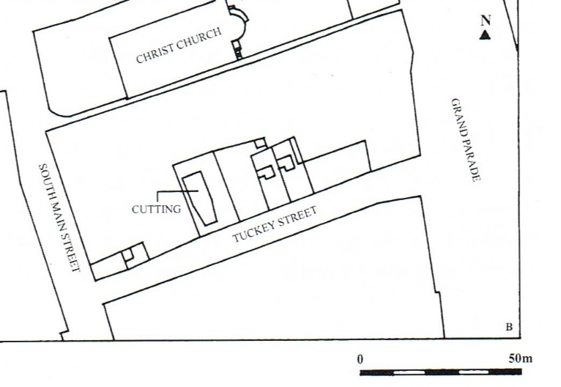
At the surface of the introduced clays, earth-cut drains and pits were found at the southern end of the site while hearths, and upright timbers were found at the northern end. It was not possible to ascertain if the timbers were associated with structures. Smaller dumps of material were laid down in a more patchwork manner and some evidence of metal working was found dating from the late 12th and early 13th century. In the early 13th century wattle fences were erected running east-west across the centre of the site. Although not necessarily related to the fences, layers of clay were deposited across the site over a long period of time and two stone walls were identified in the southeast corner of the trench, one of which may have been associated with the footing for a sill beam house. In the mid to late 13th century pits were dug and timbers laid down on the site, a gravel track extended east-west across the trench on the approximate line of the original early 12th century timber fence suggesting continuity of the property boundary. A number of stone-lined drains were also associated with these levels and the remains of a stone wall foundation. A layer of mixed rubble approximately 1.5m deep overlay this material.
Figure 14: Location of trench (cutting) opened in 1997 on Tuckey Street (O’Donnell 2003)

2.14 Outside of the park archaeological investigations were undertaken in 2008-9 in the existing Christ Church immediately to the north of Christ Church Lane in advance of its refurbishment. Sixteen trials pits and bore holes were excavated. The upstanding building was constructed in 1720 but there was a church on the site since at least 1185. Foundations for the 18th century building were found to have truncated articulate human remains at a depth of 0.6m below existing ground level in the northern part of the aspe. At the southwest of the church a brick crypt was exposed at 0.7m below the existing church yard surface and within the crypt disarticulate remains were found at 0.45m below the existing round level (Sutton 2008).

2.15 An overview of the excavations that have taken place within the block that includes Bishop Lucy Park can conclude that while a relatively large amount of archaeological excavation has been undertaken there in the last 50 years, the areas of the park which were completely excavated to medieval levels were quite small. Nonetheless the information derived from these excavations has proved very informative in relation to the proposed development of the park.

Although the Tuckey Street excavation of 1997 is outside the footprint of the park its proximity makes it relevant to the emerging story and it has produced the earliest evidence for the development of settlement in this area. In the early 12th century clays were deposited here to raise and reclaim ground level and an east-west timber fence was erected, probably as a property boundary (O’Donnell 2003). The excavated area was quite small but it is possible that the timber fence may have been an original property boundary extending east from the South Main to the city defences. Extensive reclamation layers were found in the 1985 excavation (Hurley 1989) towards the eastern end of the site, with evidence of timber ramps and fences to facilitate access for dumping mostly domestic rubbish above the riverine muds, particularly as the ground dropped away towards the watercourse to the east (Hurley 1989). By the end of the 13th century the depth of reclamation material appears to have been sufficient to allow occupation to commence and house remains from this period were found. House remains from this period and earlier were also found closer to the South Main Street, in the investigations carried out by Twohig in the 1970s (Cleary, 1997). Post and wattle houses, sill beam houses and associated occupation deposits were found in Trenches C and H dating from as early as the mid 13th century into the later 13th and 14th centuries.

At the eastern end of the block excavations were undertaken on the city wall in 1981 (Hurley and Power 1981) and 1984 (Hurley 1985). The earlier excavation revealed 17m of the wall running north from Tuckey Street and the 1984 excavation revealed 22m of wall running south from Christ Church Lane. The unexcavated portion between the two investigations is approximately 5m wide. The 1981 excavation at the southern end of the park, revealed a structurally consistent portion of wall, 2.35m wide at the top 4m wide at the base, comprising two well-built faces with a rubble core, the inner western face on average 1.3m high and the outer eastern one 2m high and battered. The outer face sat on a stepped foundation of two, three or four courses and the inner face on a foundation of at least one course.

In contrast, the 1984 excavation found the northern end of the wall varied along its course, representing more than one phase of construction. Hurley (ibid) thought that an earlier perpendicular wall, Wall 2, may represent part of a dock or mooring stepping inside the run of the city wall. He suggested that in the 16th or 17th century the city wall was extended to run in a continuous line and the ‘dock area’ was subsumed inside the city wall at this time. The city wall, as revealed in this excavation, was built in at least two phases indicated by a straight joint apparent 5.5m from the southern edge of the excavation where the wall turned slightly. Where the two construction phases met the outer, eastern, face of the wall was married together across the joint to present as a single unified structure and conceal any apparent weaknesses on the outside face. The inner western face, however, revealed the weaker, more compromised nature of the northern section which was interpreted as a later modification to the city, wall possibly in the 16th or 17th century. Further differences were apparent in the southern end of the city wall where Wall 2 was partially demolished to accommodate its incorporation into the main wall. A contrast in the construction of the city wall was apparent on both sides of its intersection with Wall 2. To the north of Wall 2 the city wall was more roughly constructed and the excavator suggests this portion of wall was not intended to be seen due to its rough appearance.

Wall 2 was exposed for 4.5m running west from its intersection with the city wall to the western edge of the 1984 excavation. It was battered on its southern side where substantial occupation material from the mid thirteen century onwards was found. In contrast, its northern face was vertical and no evidence of occupation material lay outside it, instead estuarine clay was found. This area north of Wall 2 was interpreted by Hurley (1985, 69) as having originally been outside the medieval city with Wall 2 forming the southern wall of a dock. He notes that a mid 16th century map of Cork held in Trinity College, Dublin shows a recess in the city wall between Tuckey St and Christ Church Lane and he suggests that this may correspond with the dock set inside the line of the city wall at this location. The inner wall of this dock was not located and Hurley suggests that it may remain, subsurface, in an unexcavated area (5m wide) to the west. This 5m area connects to the eastern edge of Area A which was partially excavated in 1975 (Fig. 10). It is also possible that Wall 2 extends into Area A as this area was not excavated to medieval levels in 1975-7 (Lane pers comm.). There is no written account of excavation of Area A (Cleary 1997, 97).

Human remains were found in the 1984 (Hurley 1985) and in 1985 (Hurley 1989). In both cases the remains were found ex situ, in pits excavated into the later rubble deposits. It is speculated that the human remains may have originated from the nearby Christ Church graveyard. It is therefore, likely that the remains are of medieval date, moved during later grave digging or other disturbance. They were generally weathered and were described as the more resilient bones which would survive surface weathering (Ó Donnabháin in Hurley 1985). The small scale investigation in Christ Church in 2008 verified the previous disturbance of burials within the graveyard by the construction of the existing church in the early 18th century. Disarticulate remains were found at a depth of 0.45m below existing ground level (Sutton 2008). However, it is likely that the disturbance to the burials extends beyond the footprint to the existing church building and may extend to much of the graveyard.

3 Impact Assessment and Mitigation
3.1 The archaeological excavations which have taken place within Bishop Lucy Park provide an informative overall picture of the development of the park since the 12th century. The emerging picture is of street-fronting houses along the western side of the South Main Street from the mid 13th century and into the early 14th century with long burgage plots extending to the defensive city wall at the east. Outside the wall there was a water channel and at this point the wall may have accommodated a dock or mooring which appears to have been inside the line of the (later) city wall. In the 16th or 17th century, probably when this dock was silted up, the wall may have been realigned to incorporate the inward step of the dock and run in line with the larger defensive wall.

Back inside the city wall, evidence of activity from the first half of the 12th century was identified at the southern side of the block. Here the initial layout of property boundaries in the form of fences was evident. This was followed by extensive reclamation through deliberately dumping layers of clay and contemporary domestic refuse to raise the ground level. The western end of the site along South Main Street was higher than the eastern end and occupation started on this higher ground. The ground to the rear sloped naturally eastwards towards the wall and watercourse and was probably subject to flooding; this is where the deepest reclamation levels were found. By the last quarter of the 13th century sufficient reclamation was complete to allow for occupation of the eastern end of the block and a substantial build-up of habitation material was found from this time. After a peak in the 13th and early 14th centuries, excavation showed that activity in the city tapered off as the 14th century progressed. This was in line with a nationwide pattern of urban decline in the 14th century prompted by sustained political unrest and warfare and exacerbated by the arrival of the Black Death in the middle of the century. These factors led to a massive population decline particularly in the densely populated towns and cities. Cork city survived this decline and eventually began to prosper again in later centuries. However, later medieval activity is poorly represented here and there are two possible explanations. Firstly, post medieval activity may have removed this material or secondly, and most likely, a paucity of remains from the 15th and 16th century is a common factor in many Irish urban excavations (Hurley 1995, 47-63) and is apparent here too. Hurley noted the conspicuous absence of artefactual remains made from skeletal materials (suchas antler, horn and animal bone) of late 14th to late 16th century date from the remains recovered at Christ Church (Hurley 1997, 239).

3.2 The five excavations undertaken within the block confirm the importance of the sites location within the historic core of the city. They also verify a number of core archaeological constraints relating to the proposed development, as follow:
- Substantial archaeological remains survive on the site sealed below a layer of rubble approximately 1m-1.5m deep. Below the rubble approximately 1.5m-2m of organic-rich, waterlogged archaeological deposits exist. The lower deposits date from as early as the 12th century, with the main concentration of medieval activity dating from the 13th to the early 14th century. It is likely that this density of similar contemporary archaeological material exists across the site. It is possible, of course, that there may be local pockets of disturbance.
- The lower courses of the city wall are exposed, at the eastern side of the site. These remains have been archaeologically resolved and conserved under archaeological supervision. It was not possible at the time of the excavation of this wall to further investigate a second wall (Wall 2) and possible dock area inside the west side of the city wall. The precise location, scale and nature of this dock is uncertain but it probably lies in an unexcavated/partially excavated portion of ground to the west of the city wall.
- The excavated stratigraphy outside the city wall comprised dumped layers which contained medieval material. However, in situ medieval settlement was not found and is not expected to be found outside the wall.
- Ex situ human remains, probably from the grave yard at Christ Church, were found in two charnel pits towards the east of the site. These exhibited signs of surface weathering and were re-deposited in the pits probably in the 19th century. The extent of this redeposition is not certain and may extend to other parts of the site.
- The remains of Hopewell Castle may have been uncovered during ground works in the 1980s outside the city wall at the northeast of the site but this was not verified.
3.3 The parks proposed redevelopment incorporates a number of new structural elements as follows:
A raised plinth running east-west through the park from South Main Street to the city wall
A tower in the southwest corner of the plinth adjacent to South Main Street
A shelter in the northwest corner of the plinth close to the existing fountain
A pavilion at the eastern end of the plinth and park overlooking the city wall
Exposing additional parts of the city wall and constructing a bridge across it
Insertion of lighting in the Christ Church graveyard

3.4 The plinth is proposed as a hard surface extending east from South Main Street to the city wall at the east of the park. It will be raised above existing ground level at South Main Street to accommodate root protection zones and mitigate impacting underlying archaeological deposits. The plinth will fall gently eastwards towards Grand Parade but will remains above existing ground levels, elevated slightly above surrounding ground. Ground reduction required for the plinth will be minimal as it is a slightly elevated feature. The archaeological impact of its construction is expected to be negligible. Archaeological monitoring of ground works is recommended.

3.5 The tower in the southwest corner of the plinth close to the South Main Street entrance lies within the footprint of Trench H excavated to medieval levels in the 1970s (Cleary 1997) (Figs. 10 and 15). The tower may be constructed of precast concrete which will sit on a raft foundation and or discrete piles. Ground reduction will be confined to a relatively small area minimising impact on underlying deposits. Its location within an archaeologically resolved area significantly mitigates its likely impact on archaeological deposits which is expected to be minimal. Archaeological monitoring of ground works is recommended and limited excavation may also be required.

3.6 The shelter in the northwest corner of the plinth lies largely within the footprint of Trench C partially excavated to medieval levels in the 1970s (Cleary 1997) (Figs. 10 and 15). It will sit on a raft foundation and or on discrete piles. Ground reduction will be confined to a relatively small area minimising impact on underlying deposits. Given its location within an area which was partially archaeologically resolved its impact on archaeological deposits is expected to be minimal. Archaeological monitoring of ground works is recommended and limited excavation may also be required.

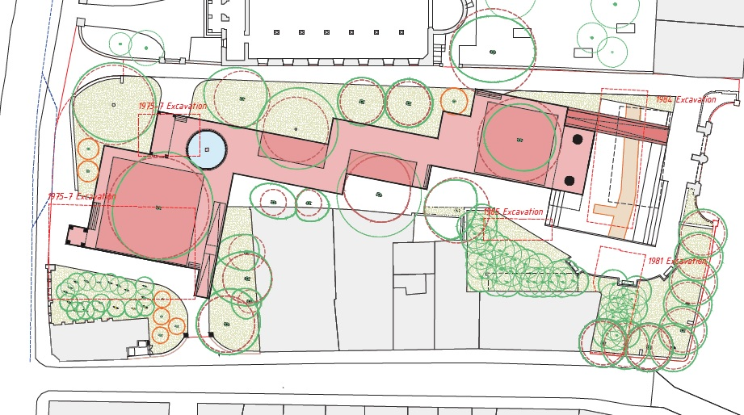
Figure 15: Layout of scheme with previous archaeological excavations outlined (after Hall McKnight Architects)
3.7 The pavilion overlooking the city wall and the Grand Parade will be supported on piled foundations. The excavations from the early and mid 1980s indicate that occupation layers from the mid 13th century exist immediately to the west of, or inside, the city wall. Furthermore, the 1984 excavation indicates that there are additional medieval masonry remains (Wall 2) adjacent and to the west of the city wall. The excavator (Hurley 1985), hypothesised that this formed part of a dock or mooring area and that associated structural remains may survive in an unexcavated area to the west or within Area A which was excavated to post medieval levels only in the 1970s (Lane pers comm). Hurley (ibid.) proposed that this would comprise a north-south wall parallel and to the west of the city wall. If such a feature survives it is likely that its preservation in situ would be required. Given the archaeological sensitivity of the area and the unresolved location of additional components of the possible dock, archaeological testing will be required within the footprint of the proposed ground works, including piles and pile caps for the pavilion foundations. Archaeological excavation may be required thereafter, depending on the results of the testing.

3.8 It is proposed to further expose portions of the city wall in addition to what is currently visible. Additional areas will be opened to the north and south of the visible section to present a length of the city wall approximately 26m long running south from Christ Church Lane. Adjoining ground will be lowered and opened up to facilitate physical access to both sides of the wall (Figs. 16 and 17). The existing steps at the eastern side of the wall will be modified and steps will be added to the western side. The steps at the western side will be located immediately southwest of the pavilion. The steps will access a sunken area approximately 1m deeper than existing ground level and extending for approximately 10m to the western elevation of the city wall. A very small portion of the proposed steps lie within the footprint of the 1985 (Hurley 1989) archaeological excavation trench and a portion of the proposed landscaped area at the foot of the steps and adjoining the western elevation of the wall lies within the footprint of the 1984 excavation (Hurley 1985) (Fig. 15). Archaeological excavation will be required of additional ground not archaeologically resolved in the 1980s, this will include a small section of city wall not previously investigated. Excavation will be required to below the level of proposed finished surfaces to accommodate insulations, blinding etc and an appropriate buffer.

To the east of the city wall a reflective pool of tidal water will extend south from the proposed bridge crossing the wall. Most of this area is within the 1984 excavation footprint (ibid) which is currently within the sunken viewing area lower than the level of the city wall. Some additional ground reduction to a depth approximately 1.77m below existing will be required at the south of the existing sunken area to accommodate the tidal pool (Fig. 15). A subsurface plant room will be required nearby to maintain the reflective pool, the proposed location of this may be to the southeast of the pool. Archaeological excavation will be required of additional ground not archaeologically resolved in the 1980s followed by archaeological monitoring during construction.

A 5m stretch of the city wall lying between the two 1980s investigations remains un-excavated. The trenches, opened to the north and south of the unexcavated section, were relatively narrow, measuring 7m and 5m. Archaeological excavation of the unexcavated section of city wall will be required in advance of proposed development. The section of city wall exposed in this excavation will require conservation and stabilisation to ensure its continued preservation.

Archaeological excavation within the footprint of the proposed ground reduction will be required for all previously unexcavated areas on both sides of the wall. The ground to the east of the city wall is likely to be composed of largely post medieval infill at the upper levels, with potential redeposited medieval strata and finds at lower levels. Archaeological monitoring of the upper strata may be appropriate combined with excavation of the lower strata, depending on the level of impact. The ground to the west of the wall is likely to be rich in archaeological strata containing organic rich, medieval occupation layers and possible evidence for a dock, incorporating medieval masonry, associated with the earliest construction of the city wall. Such deposits are considered to be of high archaeological sensitivity.

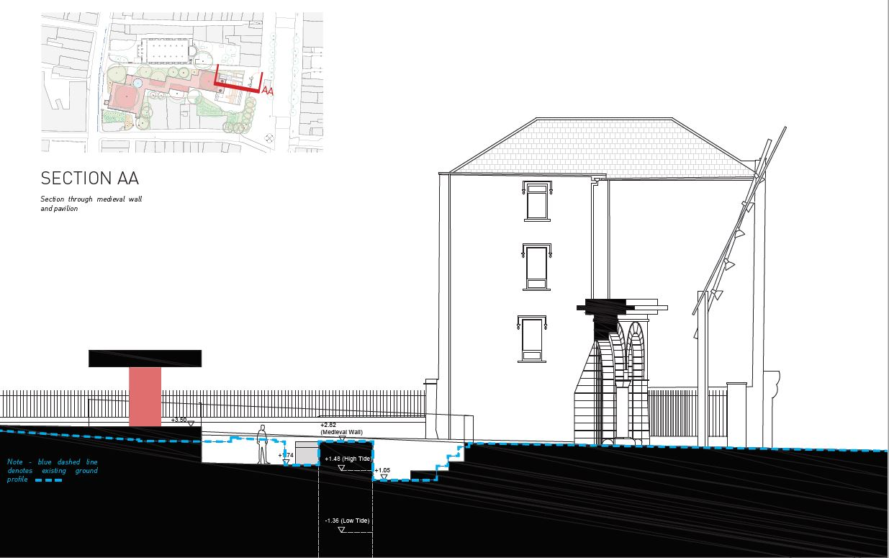
Figure 16: Proposed cross section AA across city wall (after Hall McKnight Architects)
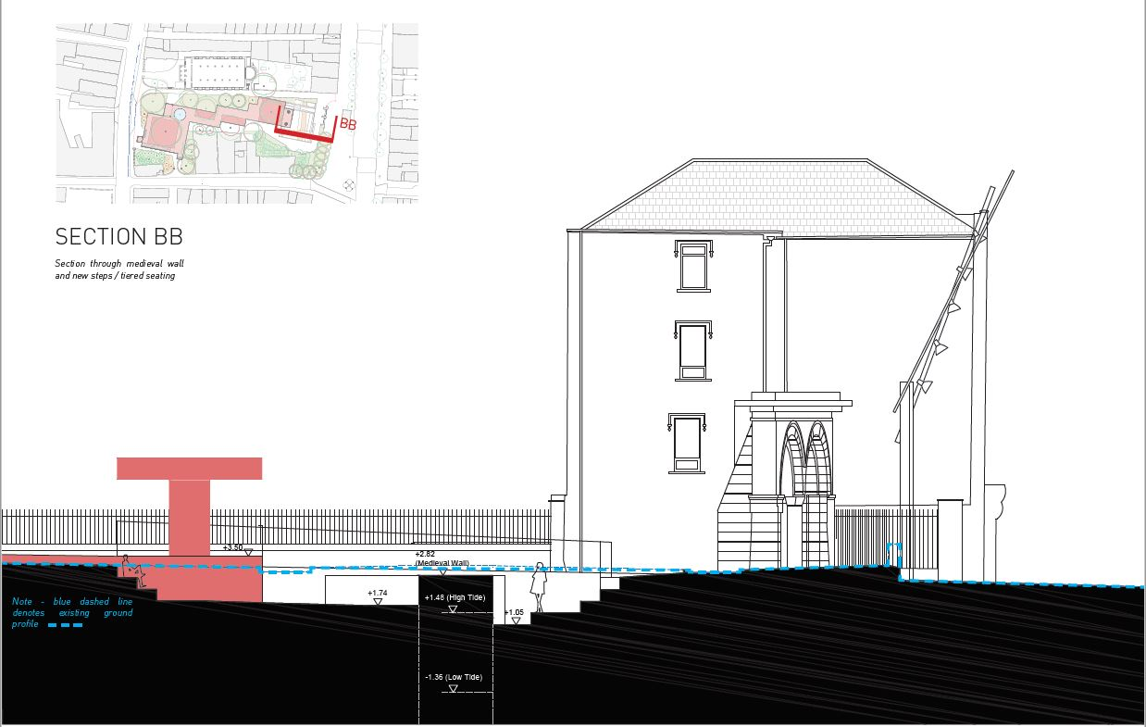
Figure 17: Proposed cross section BB across city wall (after Hall McKnight Architects)

3.10 The redeposited human remains found within the park during the excavations in the 1980s are likely to have originated in Christ Church graveyard indicating previous disturbance to the burials. Disturbance to the burials is verified by the 2008-9 investigations undertaken largely within the Christ Church building. Disarticulate human remains were found at a depth of 0.45m below existing ground level. Lighting within the park is expected to be mounted on adjoining buildings requiring minimal groundworks. Archaeological monitoring of all ground works within the graveyard will be required and limited excavation may also be require depending on the proposed extent and depth of the lighting scheme.

3.11 Pre-development archaeological testing and excavation of areas outlined above is recommended to mitigate the likely impact of the proposed redevelopment. The information derived from the archaeological testing will be used to inform and refine the design and final location of the proposal, particularly the subsurface and foundation elements. Preservation in situ of medieval masonry and in situ human remains, in particular, will be a primary consideration in the final foundation design.

Archaeological excavation by hand will be carried out on the previously unexcavated portion of city wall and adjoining ground to the west and east of the wall, followed by conservation of the city wall as required. This will be carried out to professional standards as outlined in Policy and Guidelines on Archaeological Excavation – Department of Arts, Heritage, Gaeltacht and the Islands (1999).

Archaeological monitoring of ground works during construction is recommended. Archaeological features identified during monitoring will be fully resolved to professional standards of archaeological practice. Such material will be preserved in situ or preserved by record, as appropriate, as outlined in Policy and Guidelines on Archaeological Excavation – Department of Arts, Heritage, Gaeltacht and the Islands.

Archaeological testing, excavation and monitoring must be carried out under licence or consent to the National Monuments Service (NMS) at the Department of Housing, Local Government and Heritage. Detailed method statements outlining an agreed strategy for the archaeological investigations compiled in consultation with Cork City Archaeologist will be submitted. The developer is responsible for the financial cost of the archaeological investigations and resolution by excavation or preservation in situ including the post excavation analysis of the materials recovered and compilation of the results.

3.12 All recommendations are subject to the approval of the NMS and Cork City Archaeologist. Further consultation with the NMS and Cork City Archaeologist will be undertaken.

Bibliography
Bradley J., Halpin A. and King H. (1985) Urban Archaeological Survey, Part XIV (i) Cork City. Office of Public Works.
Bradley J. and Halpin A. (1993) The Topographical Development of Scandinavian and Anglo Norman Cork in O’Flanagan P. and Buttimer C. (editors) Cork History and Society. Geography Publications.
Cleary, R. and Hurley, M. (editors) (2003) Cork City Excavations 1984-2000. Cork City Council
Cleary, R. and Hurley, M. and Shee Twohig, E. (editors) (1997) Skiddy’s Castle and Christ Church Cork- Excavations 1974-77 by D.C. Twohig. Cork Corporation
Cleary, R. (1997) Christ Church Site Excavation in Cleary, R. and Hurley, M. and Shee Twohig, E. (editors) Skiddy’s Castle and Christ Church Cork- Excavations 1974-77 by D.C. Twohig. Cork Corporation
Cleary, R. (2014) Reclamation and early development in Hurley, M. and Brett, C. (editors) Archaeological Excavations at South Main Street 2003-2005. Cork City Council
Hurley, M. and Power, D. (1981) The Medieval Town Wall of Cork Journal of the Cork Historical and Archaeological Society Vol 86
Hurley, M. (1985) Excavations of part of the medieval city wall at Grand Parade Journal of the Cork Historical and Archaeological Society Vol 90
Hurley, M. (1989) Excavations at Grand Parade, Cork II Journal of the Cork Historical and Archaeological Society Vol 94
Hurley, M. (1990) Excavations at Grand Parade, Cork II (Part 2) Journal of the Cork Historical and Archaeological Society Vol 95
Hurley, M. (1995) Excavations in Cork city: Kyrl’s Quay/ North Main Street and at Grand Parade (Part 1) Journal of the Cork Historical and Archaeological Society Vol 100
Hurley, M. and Brett, C. (2014) Archaeological Excavations at South Main Street 2003-2005. Cork City Council
Hurley M. (1997) Excavations at the North Gate, Cork, 1994. Cork Corporation
Hurley, M. (1997) Artefacts of Skeletal Material in Cleary, R. and Hurley, M. and Shee Twohig, E. (editors) Skiddy’s Castle and Christ Church Cork- Excavations 1974-77 by D.C. Twohig. Cork Corporation
Johnson, G. (2002) The Laneways of Medieval Cork. Cork City Council
National Monuments Service (in progress) Sites and Monuments Database of the Archaeological Survey of Ireland (www.archaeology.ie). Department of Arts Heritage and the Gaeltacht.
Lane S. and Sutton D. (2003) 3 and 5 Barrack Street in Cleary R. and Hurley M. 2003 Excavations in Cork City 1984-2000. Cork City Council
Ní Loingsigh, M. (2014) Houses in Hurley, M. and Brett, C. (editors) Archaeological Excavations at South Main Street 2003-2005. Cork City Council
Ní Loingsigh, M. (2014) Waterfront and Defences in Hurley, M. and Brett, C. (editors) Archaeological Excavations at South Main Street 2003-2005. Cork City Council
Ní Loingsigh, M. (2014) Reclamation in Hurley, M. and Brett, C. (editors) Archaeological Excavations at South Main Street 2003-2005. Cork City Council
Ní Loingsigh, M and Sutton, D. (2014) Introduction to the excavations in Hurley, M. and Brett, C. (editors) Archaeological Excavations at South Main Street 2003-2005. Cork City Council
Power, D. And Lane S. (1994) Archaeological Inventory of County Cork Vol 2. The Stationery Office.
Sutton, D. (2008) Christ Church (Holy Trinity), Main Street South, Cork. 2008:206 www.excavations.ie
Sutton, D. (2009) Christ Church (Holy Trinity), Main Street South, Cork. 2009:136 www.excavations.ie
Sutton, D. (2014) Waterfront and defences in Hurley, M. and Brett, C. (editors) Archaeological Excavations at South Main Street 2003-2005. Cork City Council
Thomas, A. (1992) The Walled Towns of Ireland Vol 2. Irish Academic Press, Dublin.
Twohig, D.C. (1975) Cork City, South Main Street, Cork. 1975:10 www.excavations.ie
Twohig, D.C. (1976) Cork City (South Main Street), Cork. 1976:11 www.excavations.ie
Wren, J. (1995) The City Wall at 81-83 Grand Parade, Cork in Hurley, M. Excavations in Cork city: Kyrl’s Quay/ North Main Street and at Grand Parade (Part 1) Journal of the Cork Historical and Archaeological Society Vol 100

