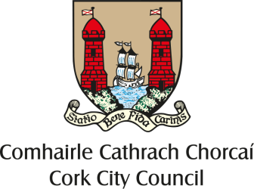

Nomination Form
Naming of new bridge to be constructed between Merchants Quay and Harleys Street.
Background

The new bridge will provide improved pedestrian and cycle connectivity in general, with particular benefits for travel between Kent Station & McCurtain Street on the northern side of the channel and Parnell Place, the City Centre & the Bus Station on the southern side.

Located on an axis with Harley Street, the bridge aims to fit sympathetically with the surrounding quays, buildings and urban realm. It will provide a convenient and accessible link across the river with minimal visual intrusion on the river vista or river channel.

The bridge is being developed with financial assistance from the National Transport Authority and the Southern Regional Assembly (under the EU funded Designated Urban Grant Scheme).

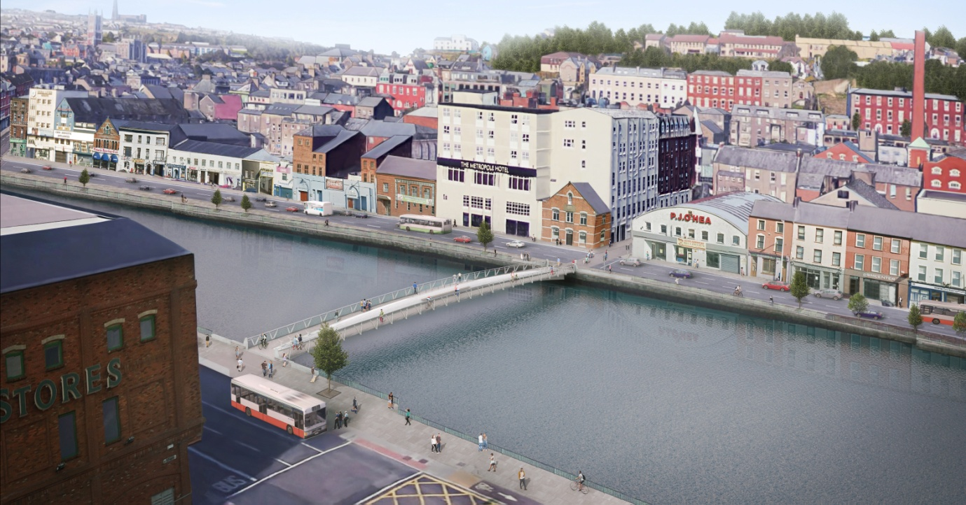
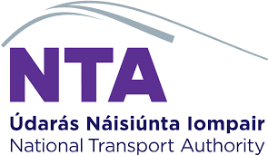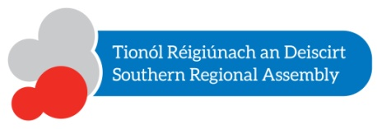

Suggested Name

Biographical/Historical Information

In respect of the person / event / organisation etc detailing the reason for the nomination.

Declaration/ Endorsement
I understand that the information provided in this nomination will be used for the purpose of naming the bridge from Merchants Quay to Harleys Street, Cork. I understand that nominations will be assessed by a Committee, with a recommendation put to full Council for final approval.

Name: ____________________________________________________________________________
Signature: _____________________________________ Date: _____________________________
Contact Tel Number: _____________________
Email: _________________________________

Contact
Nomination Forms to be returned no later than Thursday, 15th November 2018, on https://consult.corkcity.ie or to:
Fiona Dinneen, Administrative Officer, Roads & Transportation Directorate, City Hall, Cork,
T12 T997.
Tel. No. 021-4924166 / Email: Fiona_Dinneen@corkcity.ie.

Guidelines
The following guidelines are issued to assist in the nomination and selection of a name for the new pedestrian/cycle bridge at Harleys Street –
- The name should honour a significant event, individual or group/organisation or reflect important local features or geographical location

- In the case of an event or person or group/organisation the name should honour and celebrate an event, individual or group/organisation of major significance and reflect positively on the City of Cork or its development over time

- In the case of a person being nominated he/she should have made a unique and outstanding contribution to the life or history of Cork through outstanding achievement, distinctive service or significant community contribution. The person/s should have been born or lived in Cork or have had strong and/or enduring connections with the city

- In the case of an event to be commemorated, this should have occurred in Cork. An event will have to have occurred at least 20 years previously unless it is of extraordinary and long-lasting consequence to the city

- Proposals to commemorate living persons will not be considered. Nominees should have died at least 20 years previously or have passed the centenary of their birth whichever is earlier. A lesser period may be considered by Council If deemed appropriate

- The name should be appropriate to the function, location and historical context of the new infrastructure

- In reviewing proposals consideration will be given to the existence of any other infrastructure, monuments or plaques that honour the event, person or group/organisation. Consideration will also be given to the issue of gender balance

