BALLYVOLANE/DUBLIN HILL AND ENVIRONS ACTION AREA PLAN 2019

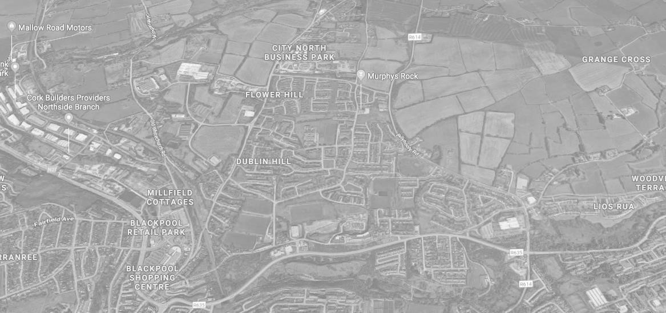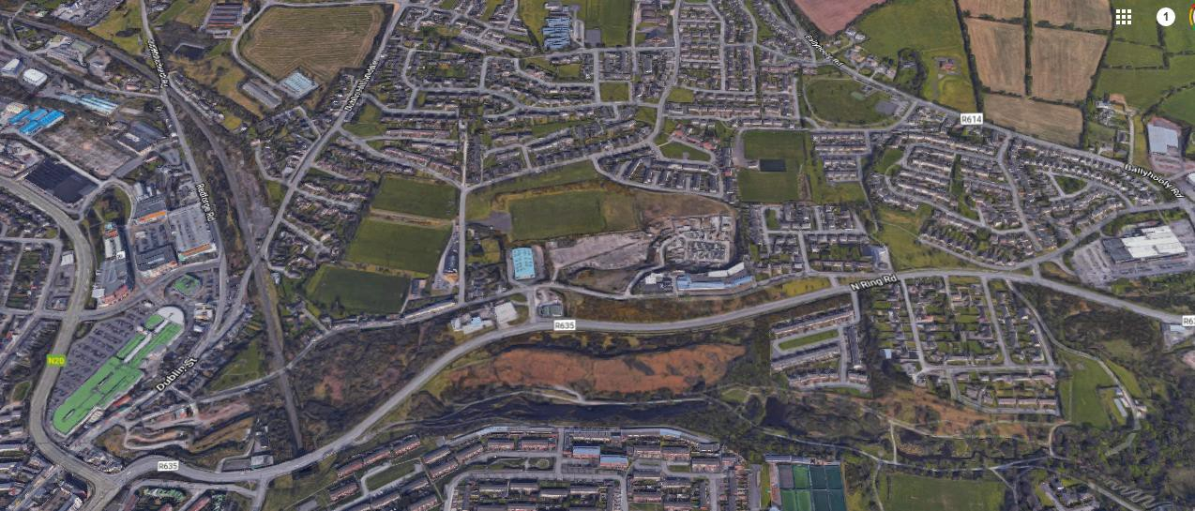

BALLYVOLANE/DUBLIN HILL AND ENVIRONS ACTION AREA PLAN

C O N T E N T S

Introduction Research and Analysis Public Consultation
Interventions/Action Plan Conclusion/ Recommendations

BALLYVOLANE/DUBLIN HILL AND ENVIRONS ACTION AREA PLAN

E X E C U T I V E S U M M A R Y
This Action Area Plan was prepared between August 2018 and May 2019 by the stakeholders of the Ballyvolane/Dublin Hill area, facilitated by Cork City Partnership and Ballyvolane Community Association with guidance from Butler O’Neill Total Planning Solutions.
The Ballyvolane/Dublin Hill area is a distinct settlement within the built up north environs of Cork City. It is currently experiencing a lot of pressure for growth and is on the cusp of dramatic transformation as 1,000s of new housing units are earmarked for this area and its wider surrounding area in the next few years.
This Local Area Plan/Area Action Plan is a community-led grassroots plan deeply embedded in the principles of public engagement and has been prepared to guide the future development of the area in a way that is beyond a bricks and mortar approach. In light of the future growth that is happening this plan assesses [through meaningful engagement with the community] the perceived impact of growth on the identity of the area as well as assesses whether the existing social and physical infrastructure is capable of taking such growth.
All of this is development is further exacerbated by the fact that at the time of publication of this plan the city jurisdiction will have expanded and the north environs and subject area in particular will thankfully be governed by a single entity. This situation highlights the timely need for a plan such as this and the need for a future legal local area plan for the area because historically for the last number of decades this area has effectively planned for by two local authorities with little/no joined up thinking.

To address the issues identified in the research stage of this Action Area Plan the community have developed a number of short, medium and longer term measures which need to be implemented in tandem with housing growth to ensure that the Ballyvolane/Dublin Hill area and its wider environs thrive socially, environmental and economically in line with the principles of planning and sustainable development.

The main finding of this Action Area Plan is that the Ballyvolane/Dublin Hill Area urgently requires a community building to provide for the existing and future members of the community – given its central location and the availability of council owned land the site at Kempton Park is the most appropriate location for this building.

BALLYVOLANE/DUBLIN HILL AND ENVIRONS ACTION AREA PLAN

C O N T E X T F O R T H E S T U D Y
Cork City Partnership (CCP) holds the contract for the Social Inclusion and Community Activation Programme (SICAP) 2018-2022 for Cork City.
SICAP provides funding to tackle poverty and social exclusion through local engagement and partnerships between disadvantaged individuals, community organisations and public sector agencies. Administered by Pobal and funded by the Irish Government through the Department of Rural and Community Development, it also receives funding from the European Social Fund under the Programme for Employability, Inclusion and Learning (PEIL) 2014-2020.
Using community development approaches, SICAP addresses high and persistent levels of deprivation through targeted and innovative, locally- led approaches. It supports disadvantaged communities and individuals including unemployed people, people living in deprived areas, people with disabilities, single parent families, people on a low income, members of the Traveller and Roma community and other disadvantaged groups.
The programme is managed at a local level by 33 Local Community Development Committees (LCDCs), with support from local authorities, and actions are delivered by Programme Implementers (PIs).
As part of its Annual SICAP Plans for 2018 and 2019, CCP outlined an action in relation to Area Based Planning, specifying a number of pre- identified disadvantaged areas/neighbourhoods and estates across Cork City. Developing Area Based Plans facilitates a process whereby people living in local communities can come together to identify the issues of concern to them and be central in leading out and generating solutions.
CCP sees this action as a platform to support the development of the
areas identified in its Annual SICAP Plans. In its 2018 and 2019 Annual SICAP Plans, CCP stated that it would work with a local community group in Ballyvolane , namely the Ballyvolane Community Association, to facilitate an Area Based Plan for its area.
In relation to delivering the action in Ballyvolane, CCP is a member of the EU Atlantic Social Lab Project Public Participation Working Group led by Cork City Council. Through this Group, CCP has had the support of a community planning expert.
It is through the participation of Cork City Council and the European Commission (Interreg Atlantic Area Programme) funded project called “The Atlantic Social Lab” that additional funding has been available to develop this Area Action Plan.

This project is the result of extensive public engagement and with the help of a mentor, this Area Action Plan, or local plan has been prepared by the community for the community to guide the future development of an area in Cork City for the next number of years.

BALLYVOLANE/DUBLIN HILL AND ENVIRONS ACTION AREA PLAN

- I N T R O D U C T I O N
Background to the Study
Ballyvolane/Dublin Hill is located to the north of Cork City within the existing built up area and is bounded to the north and east largely by extensive greenfield land, to the west by the Blackpool area, to the south east by Mayfield and to the south west by The Glen. The Ballyvolane area is a distinct urban neighbourhood with a separate identity and community to the other urban neighbourhoods in the north environs of Cork City.
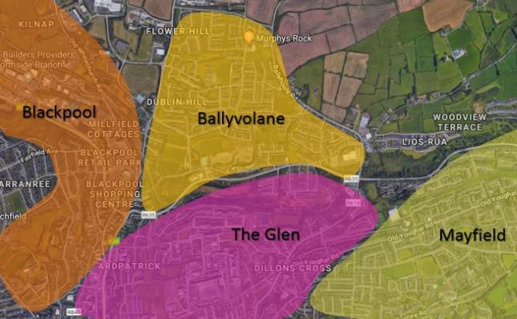
Mainly a residential settlement, with an element of retail services, the population of Ballyvolane/Dublin Hill is almost 7,000 persons in the immediate area (CSO, SAPS: 2016). The adjoining areas are inextricably and functionally linked to Ballyvolane Environs and the people in Ballyvolane/Dublin Hill rely on other areas such as Blackpool and Mayfield and the Glen for community facilities, educational facilities and non-convenience shopping. In saying that the area is substantial enough to be recognised in its own right and the people of Ballyvolane/Dublin Hill associate themselves with being from a distinct community as opposed to being from one of the other three areas in the northside of the city.

Four Distinct Identity Areas Within Close Proximity

In the absence of this area being recognised as a distinct urban community and in the context of the exponential growth that the area is facing, it is considered that the people of Ballyvolane/Dublin Hill lack a specific future ‘vision’ for the social, economic and environmental development of the area. The only certainty that the people in the area have is the fact that the area is destined for significant housing development on lands within the area and that the area will [by the time this document is published] be within the functional area of a single local authority which will make it more coherent to govern as a result.

Who we are
This project is the result of a collaboration between Cork City Partnership and Ballyvolane Community Association with support from Cork City Council under the European Social Inclusion Fund.
The Ballyvolane Community Association has been in existence since 1988 it is also known as the Ballyvolane/Dublin Hill Development Group. The purpose of the group was to organise and provide amenities within the area of Ballyvolane/Dublin Hill and liaising with other groups and organisations both statutory and voluntary. The overarching objective of the Association is to create a vibrant, safe community for residents and one of the main focus points of the group over the years has been to work to develop a community/resource centre within the area.
Cork City Partnership has been in existence for 25 years. The work of ‘partnership’ is about creating the conditions for dialogue so that there is a better understanding of ‘what will work’ and make a positive difference in the lives of individuals, families and communities. The fundamental

BALLYVOLANE/DUBLIN HILL AND ENVIRONS ACTION AREA PLAN

principles of the Partnership align exactly with the key principles and aims
underpinning this Action Area Plan which are:

Aims
ENGAGE directly and honestly with individuals, their families and communities; and working in ways that are directly relevant to the challenges and opportunities that become apparent;
LEARN from experience and collating the various forms of data that we produce and can access;
COMMUNICATE an informed view of the reality of people’s lived
experience as we address the causes of poverty and social exclusion;
CONNECT communities that experience disadvantage with the services that they need;
MAKE SENSE of national government policy by commenting on policies and decisions that directly impact on the lives of people and on groups who live with inequality and limited access to education, health and community services

Key objectives and aims

Guiding Principles
Coherent Identity: A United Settlement
A Vital Urban Neighbourhood
High Quality Urban Design and Place-making
Social and Community Infrastructure
Connectivity and Accessibility

Clear Vision
for the future development of Ballyvolane/Dublin Hill

BALLYVOLANE/DUBLIN HILL AND ENVIRONS ACTION AREA PLAN

Context for the Plan
It is considered that the last number of years have drastically changed the nature, identity and function of the Ballyvolane/Dublin Hill area and the North Environs in its entirety. This Action Area Plan will examine evidence and the views of the community in an attempt to make key recommendations and short and medium term priorities for the settlement of the Ballyvolane/Dublin Hill area for the next number of years.
Objectives

- Identify the major challenges facing Ballyvolane/Dublin Hill in terms of employment, education provision, environmental and pedestrian realm, social infrastructure and community services
accessibility;

- Develop a clear understanding of the definition, boundary, identity and function of ‘Ballyvolane/Dublin Hill’ as a clearly identifiable, distinctive and recognisable functional urban district and high quality urban neighbourhood on the periphery of Cork City Centre;

- Define the challenges facing the area at the time of the consultation and the development of key strategic and integrated responses to the challenges facing the
area;

  - Establish a set of agreed core interventions that will guide the future development and management of the area in the short,
medium and long term; and

- Identify specific revitalisation measures for the Ballyvolane/Dublin Hill area, underpinned by fostering and cultivating social capital in
the area.
The plan will identify the current levels of social infrastructure in the area and identify any deficits in the provision of, or availability of, services to the people of Ballyvolane/Dublin Hill. There is a need to inform a future Local Area Plan or a specific part of the future Municipal District Local Area Plan with specifics on this area as there is no specific mention of this particular urban neighbourhood in planning policy. There is also a need to guide service providers and developers towards the provision of services/facilities where they are needed.

Accordingly, this Action Area Plan is primarily concerned with the social vibrancy and vitality of the area and the various social/community measures that are needed in tandem with key physical, transport, movement, accessibility/connectivity developments that are needed to support the area. It represents a comprehensive and integrated strategy that promotes Ballyvolane/Dublin Hill as a distinct urban neighbourhood within the north environs of the city and welcomes actions from Cork City Council that support this.

BALLYVOLANE/DUBLIN HILL AND ENVIRONS ACTION AREA PLAN

- S T U D Y A R E A - strategic level
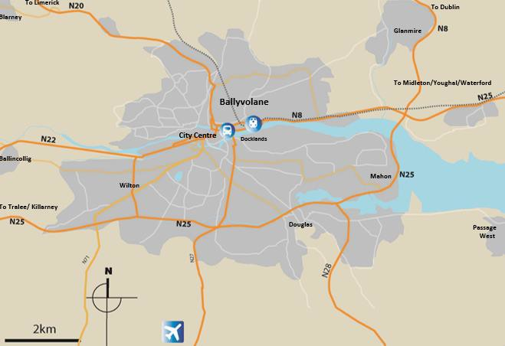
Image: Ballyvolane/Dublin Hill within Metropolitan Cork Area

- Strategically located at the Northern periphery of Cork City
- High quality road network, accessible to all primary road networks (N20, N25, N22, N8), the Jack Lynch Tunnel, Cork Airport and the Port of Cork.
- Possibility to be connected to the existing Cork- Mallow railway line
- Within short distance of the city centre.
- Located in close proximity to Third Level Institutes where over 35,000 students attend daily.

BALLYVOLANE/DUBLIN HILL AND ENVIRONS ACTION AREA PLAN

S T U D Y A R E A - local level analysis
The Ballyvolane/Dublin Hill area is well spread out reaching from Dublin Hill Upper to Ballincollie Road and Riverview Estate and Pynes Valley along the North Ring Road. The area has some 22 housing estates within its confines and over the coming years this will grow exponentially as there is a large amount of residentially zoned land in the area and a large amount of Greenfield lands to the north of the built up area of Ballyvolane/Dublin Hill.
There are also pockets of one off housing all around the area. Information from the last census shows the population to be 6,696. The community has two schools, one primary school, Scoil Olibheir which over 600 pupils attend and one second level school St. Aidan’s Community College which over 700 pupils attend. There is one church called Saint Oliver Plunkett Church and there is one crèche Glenfields community crèche located in Glenfields Park.

Existing Community Facilities
In terms of amenities, there is one amenity park situated in Kempton Park. This contains a walking/running track, a small playground, a soccer/kickabout area and two tennis courts but these are not in use. Two porta cabins are located in the park also. One was donated to the Ballyvolane Community Association and is used by Foroige and is funded under the Cork Local Drugs/Alcohol Task Force. There are no Youth Workers in the area and no Youth Clubs or youth Cafes etc. The second porta cabin, was also donated and it houses the recently formed The Glen/Ballyvolane/Dublin Hill Men’s Shed group. There is a room within the Community Creche building which is used by Ballyvolane Ladies Group which caters for the senior ladies within Ballyvolane/Dublin Hill area. A widows and widowers group also use these facilities in the creche in the evening when they are available as there is no resource
centre/community centre for them to go to. A number of sporting clubs
operate within the area between GAA and soccer. These clubs do offer their facilities to the community association when they are available but no community education classes can be held on a regular weekly or monthly basis as the rooms are in use by the clubs themselves.

First element of Public Participation/engagement
In 2017/18 an extensive survey was undertaken by the Ballyvolane Community Association with support from Cork City Partnership. A number of students from the Youth & Community Degree Course in University College Cork undertook placement with the Cork City Partnership Glen Outreach Office. While on this placement, a physical survey of the area was done to ascertain the land use [residential/ commercial/ community] of each building in the area. A number of qualitative studies were also conducted the primary findings were:
  - A perception of a general lack of investment in infrastructure in the area.
  - An analysis needed to identify the deficits in infrastructure [social, economic, environmental and physical].
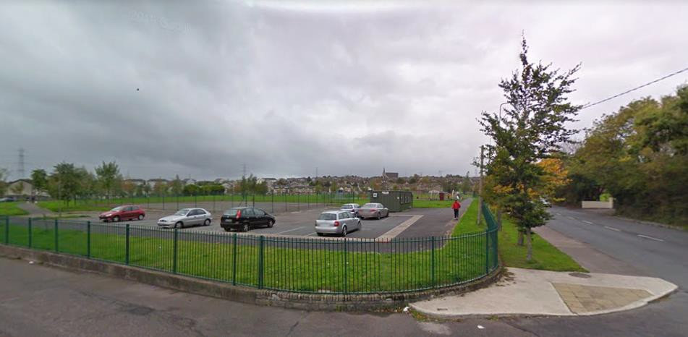

Image: Kempton Park

BALLYVOLANE/DUBLIN HILL AND ENVIRONS ACTION AREA PLAN

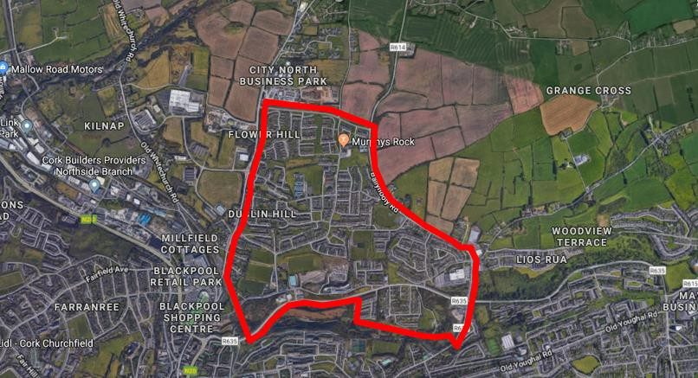
Image: Outline of Ballyvolane/Dublin Hill area

BALLYVOLANE/DUBLIN HILL AND ENVIRONS ACTION AREA PLAN
- S T U D Y A R E A - strategic policy context
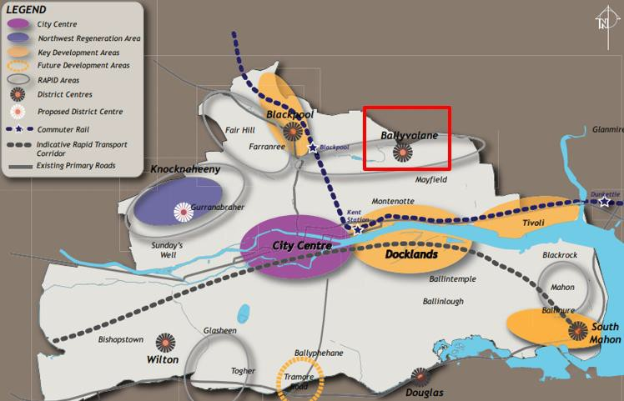
Ballyvolane is outlined in the Cork City Development Plan 2015-2021 as a ‘District Centre’ (CCDP, 22). The district centres are Mahon, Douglas and Wilton District Centres on the south side, and Blackpool and Ballyvolane District Centres on the north side. According to the plan retailing to serve the local market will be the primary function of district centres. The long term objective is that these centres would over time evolve into mixed use urban centres with good public transport access and high quality urban design.

The plan states that demand for additional comparison retail floorspace in Ballyvolane will be driven by future population growth in the northern suburbs. In addition the Plan states that “Delivery of comparison floorspace and ancillary services should be accompanied with a range of ancillary retail services, community and social infrastructure.”

Image: Cork City Development Plan Policy

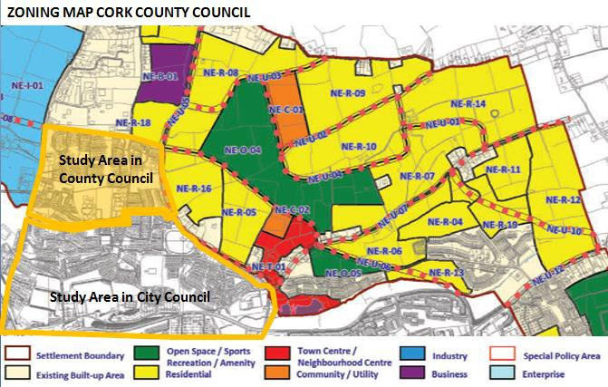

ZONING MAP CORK CITY COUNCIL
BALLYVOLANE/DUBLIN HILL AND ENVIRONS ACTION AREA PLAN

Perhaps the main reason why there is no coherent vision for the future of the Ballyvolane/Dublin Hill area is because until very recently this Action Area Plan the area was governed across two local authorities. As can be seen from the zoning maps the area is still zoned across two separate development plans which makes achieving a unified vision or collective set of development objectives for the area very difficult.

Ballyvolane is one of Cork’s oldest suburban housing areas which is associated with the strong industrial and employment functions associated with nearby Blackpool as well as the city centre. Today Ballyvolane still retains its position as an attractive residential destination in the northern environs in Cork City.
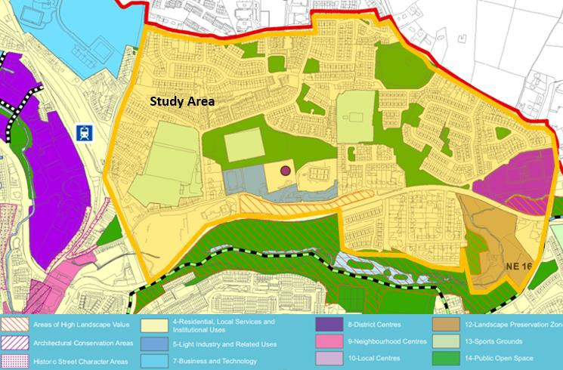Light industry as well as business and technology play an important employment and economic role in the north environs and the residential function that the Ballyvolane area [current and future] plays is fundamental to the ongoing economic success of the nearby employment areas.

As one of the less disadvantaged areas in the North Environs when it comes to social and community infrastructure an initial look at the research area reveals that it has been somewhat left behind with regards to the quantum and availability of social services and infrastructure.

BALLYVOLANE/DUBLIN HILL AND ENVIRONS ACTION AREA PLAN

Opportunity to acknowledge the place as a single entity

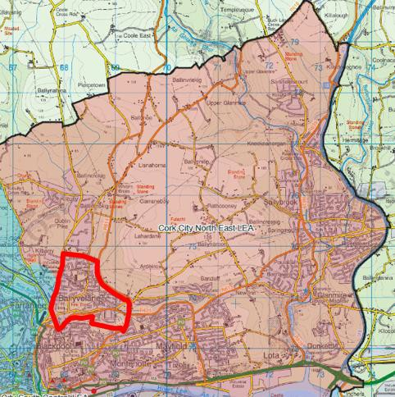
It is difficult to understand the vision for the future development of the area when it located across two plan areas and further exacerbating this is the fact that they are across two separate local authorities.

At the time of writing, about 60% of the area was located in the City Council Area and 40% was located in the County Council Area. Following the Boundary Extension the entire study area will be located within the City Council Functional Area this is particularly welcomed and should lead to more coherent planning for social, community and physical infrastructure in particular.

BALLYVOLANE/DUBLIN HILL AND ENVIRONS ACTION AREA PLAN

Area Profile - Deprivation
Ballyvolane/Dublin Hill is a recognised townland and suburb of Cork on the north east side of the city. It is bordered by Mayfield, The Glen and Blackpool. There are functional links present between the four communities which tie them all together physically, socially and economically. The road infrastructure is the most obvious physical link and the public bus service consolidates this tie. The main economic link among the four is with Blackpool as that is the major employment and retail centre with circa 15,000 persons working in the area. Socially the people of Ballyvolane/Dublin Hill rely on other communities for non sport related social infrastructure. A statistical profile of the area enables the identification of particular areas of need in relation to community facilities and housing.
In statistical terms the study area comprises 25 Small Areas according to the Census Small Area Population Statistics [SAPS]. The 25 Small Areas are contained within the following Electoral Districts (EDs):
  - The Glen A (2)
  - The Glen B (14)
  - Mayfield (1)
  - Rathcooney (2)
  - St. Mary’s (5)
  - Commons (1)
The area cuts across the Cork City and County boundaries and as such it is difficult to plan for and provide for a single area of identity across two completely different local authorities. The new plan [anticipated in 2021] will join together these areas and the wider greenfield hinterland and provide a coherent vision for the future development of the area. As a number of planning applications are already lodged there is a need
for this plan in the interim period as well as in general to guide the short
to medium term development of the area.
An analysis of the small area information identifies that the area as a whole is below average in deprivation terms. When compared to Mayfield and the Glen etc Ballyvolane/Dublin Hill would be relatively affluent and as such has probably not received the same attention over the years in terms of investment as the other areas in the northside. There is a spread of deprivation designation with values ranging from

10.89 (Classified as ‘Affluent’ - Lios Road/East Avenue/Park Avenue East area) to -23.9 (Very Disadvantaged – Fire Station/portion of the North Ring Road area). The spread is shown in the table below.


Deprivation level
12
10
8
6
4
2
0

Deprivation Level in the EDs making up the built up area

BALLYVOLANE/DUBLIN HILL AND ENVIRONS ACTION AREA PLAN

Population/Age Profile
The total population of the Small Areas which make up the Ballyvolane/Dublin Hill area is 6696 persons. Strikingly this equates to 5.33% of the total population living in Cork City.
Looking at the age profiles within the Small Areas, the older age ranges appear most often and 65-69 year olds are the most dominant age group in the area. This is interesting because there does not appear to be any targeted services for older people and the age profile indicates that medical services, meals on wheels, accessible housing, social services such as bingo etc. should be carefully considered. There are distinct pockets of younger people in certain areas such as Dublin Hill Middle/ Thorndale Estate where the predominant age range is 25-29 years. The total number of the population of 6-17 years in this area is 1189 or 17.76%.
The number of children aged 0-5 years in the study area is 526 or 7.86% of the total population, whilst the number of over 60s is 1250 or 18.67% of the total population this is extremely notable as it highlights less of a need for immediate additional services such as childcare/creche services and a greater need for services for older persons.
Age dependency ratios vary across the Small Areas from 23.85 (Thorndale Estate) to 50.44 (Glenthorn Park/Glenthorn Way areas). The age dependency ratio is an age-population ratio of those typically not in the labour force (the dependent part ages 0 to 14 and 65+) and those typically in the labour force (the productive part ages 15 to 64).

Families/children
There are 1909 families living in the study area, with 2649 children. Of these families, 590 families (30.9%) are lone parent families. This is a significant number and well above the cork City average of 23.1%. The lone parent ratio varies widely between Small Areas, ranging from 6% to 71%. Certain supports for single parent families could be considered in this area.

Housing
The proportion of Local Authority rented accommodation in the study area is 11.82% which is below the city average of 16.5%. Traditionally this area would have housed a large proportion of local authority housing much of which has been incrementally privatised over the last 20 or so years. 19 out of the 25 Small Areas have 7% or less of the housing stock which is local authority rented.
Across the area there are 108 vacant dwellings.

Health
Of the total population within the study area, 1048 (15.65%) people identified in the 2016 Census as having a disability. This is slightly under the percentage of people with a disability in Cork City as a whole at 18.1%. From a planning perspective the number of disabled accessible housing should be considered when appraising new housing developments, acknowledging that not all disabilities are physical, social supports for those with mental illness or intellectual disabilities should also be considered.

BALLYVOLANE/DUBLIN HILL AND ENVIRONS ACTION AREA PLAN

Unemployment
Unemployment rates for men across the Areas range from a low rate of 2.6% (Lios Road/East Avenue/Park Avenue East) to the significant level of 35.71% (Park Court/Leeds Park/Ballyvolane Business Park areas). Female unemployment shows a similar range from 1.41% (Mervue Lawn/Mervue Crescent) to 35.29% (Fire Station/North Ring Road areas). Unemployment levels amongst women need not necessarily be reflective of any particular deprivation but may reflect the women’s decision to remain in the home. The average unemployment rate is in line with the city rate.

Education
In relation to education levels in the area, again it is of note that there is a wide spread of ranges between the Small Areas. For example, when looking at the proportion of the population with primary education or less, the values range from 2% (Brookvale/Banduff Road/Rathcooney Road) to 38% (Fire Station/North Ring Road). Nine of the 25 Small Areas show at least 1 in 5 (20%) of the population as having primary education only. In Cork City as a whole the proportion of the population whose highest level of education was primary was 13.6%. Thus, in at least one of the Small Areas under review i.e. Fire Station/North Ring Road the level of person having primary education only was three times the City figure.
2742 or 62.29% of the total 4402 of the population living in the overall area aged 15 years and over had completed upper secondary or lower education levels. This is a substantial figure considering the high age profile of the area.

Migration, Ethnicity
Of the total figure of 6671 who answered the question, 6211 or 93.11% gave their nationality as Irish, 130 or 2% were Polish and 66 or 1% gave their nationality as UK. No other nationality was significant in the overall study area. Unsurprisingly Polish was the highest foreign language spoken in the area.
In terms of ethnicity the highest figure was for White Irish at 89%. There were 145 White Irish Travellers (just over 2%), 330 (5%) Other White, 90 (1.35%) Asian or Asian Irish and 36 (0.54%). Black or Black Irish.145 persons from the travelling community in the area is significant and this figure also relates to other figures for the Fire Station/North Ring Road SAP, a separate study is perhaps warranted to address and cater for the particular needs emanating from this community.

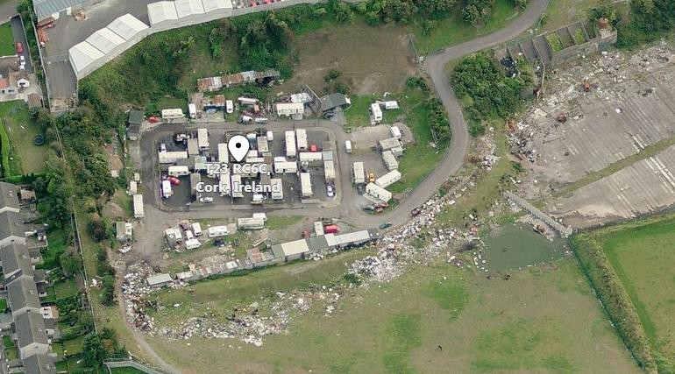

Image: Spring Lane Traveller site

BALLYVOLANE/DUBLIN HILL AND ENVIRONS ACTION AREA PLAN

PUBLIC CONSULTATION
In addition to statistical analysis which highlights particular areas or cohorts of the population that may be in need of service provision, public engagement and community/stakeholder inclusion and mobilisation is the most important aspect of this Action Area Plan and all aspects of the plan [from the aims and objectives to the final interventions and recommendations] are intended to be grassroots and bottom up. As such, the public consultation element of this Action Area Plan is without doubt the most important element and significant efforts went into ensuring engagement and consultation was at the forefront of this Action Area Plan in a meaningful way.
In September 2018 Cork City Partnership and the Ballyvolane Community Association held 3 community consultation events in the Ballyvolane/Dublin Hill area of the city. Members of the local community were invited to come along to voice what they felt were the needs and issues / challenges in this suburb of Cork City. The dates, times and locations were carefully chosen in order to reach out to as many local residents and target groups as possible.
To highlight and raise awareness of these planned community consultations community developments workers from Cork City Partnership first of all compiled an extensive area and location distribution list, secondly they organised and printed 3,000 “Have Your Say! – What do local people think?” Household information leaflets and 30 posters and finally they co-ordinated an area based door to door leaflet drop. 3O Have your Say! Information posters were also displayed in local businesses, petrol stations and various community locations across the area. This poster was also posted on the Partnership’s Facebook page as well as on the Ballyvolane Notice Board and Ballyvolane Community Association Facebook page. Project workers working in the Traveller
Visibility Group project were also contacted in regard’s to forwarding on
an invitation to members of the local traveller community whom, as previously mentioned, constitute a significant proportion of the population of the area.
Community Consultation “Have Your Say! – What do local people think?”
Day 1, was held on Wednesday 26th September from 11.00 am to 4.30pm in the car park of St. Oliver’s Church, Ballyvolane. This location was chosen because of its proximity to both the local primary and secondary level schools. Partnership staff and Community Association members were on hand to chat to the local community. There was a large Planning For Real map of the area on show which was populated with various local landmarks so people could visualise how large a geographical spread the area is.
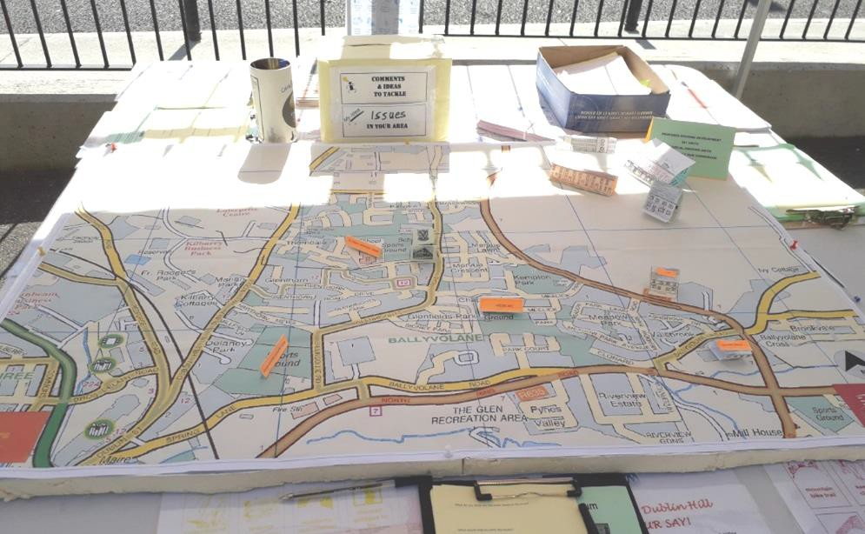
Image: Planning For Real map highlighting existing services & future housing

BALLYVOLANE/DUBLIN HILL AND ENVIRONS ACTION AREA PLAN

The map was also used to show how many housing estates there are in
and planned for this part of the city. The Partnership staff also used specifically themed questionnaires to gather information for a community needs analysis.
Community Consultation “Have Your Say ! – What do local people think?” Day 2. was held on Thursday 27th September in two locations, the first took place in Lidl Car Park, on the Ballyhooly Road, from 9.30am
- 5:30pm. The second location on the 27th was set up in Glen Rovers, GAA Club, Ballincollie Road, in the evening from 6:30 - 8:30pm. Once again Partnership staff and Community Association members were on hand to speak to the local community, with the aforementioned Planning For Real map of the area and themed questionnaires.
A separate workshop was also held with local transition year student to ascertain their views on identity and the perceived services available to them and their perception of their area.

RESULTS/FINDINGS
There was an overwhelming response of 206 persons who filled out and returned the specific questionnaire (see pg 22). In addition to this many people gave informal/verbal feedback at the consultation events held.

The resounding finding [tabulated below] was that there is a need for a Community Centre Building for the Ballyvolane/Dublin Hill area.
  - The second biggest finding is the identified need for services for youth, adults and in particular older persons and this also ties in with the ageing population statistics discussed in the area profile section of this Area Action Plan.
- Interventions for pedestrians to improve safety and
connectivity measures were also relayed by a significant amount of the respondents.
- Traffic was also a big concern particularly in light of the upcoming developments planned/permitted. What is important to note is that new development was wholeheartedly welcomed, however putting in place the necessary infrastructure to cope with the developments would be necessary.
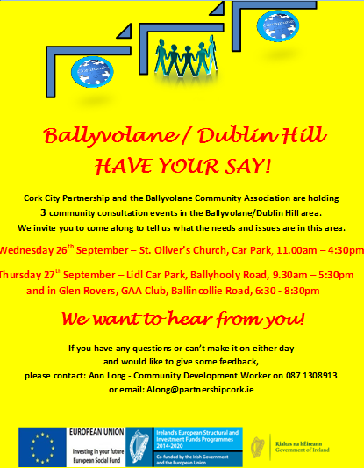
Image: Poster Advertising Community Consultation

BALLYVOLANE/DUBLIN HILL AND ENVIRONS ACTION AREA PLAN
Detailed Table of Findings
Schools | Of the 206 returned questionnaires – 38 identified the need to have new schools in the area due to the overcrowding of the present primary and secondary schools, thereby supporting future development of housing in  the area.
Environment | Of the 206 returned questionnaires – 22 identified the need for increased information on having a greener environment, clean up of  the area and bins etc. installed.
Others | Of the 206 returned questionnaires – 20 identified the need other shops and services in the Ballyvolane area e.g. Penny’s, Nursing  Homes, animal shelter.
Social Housing | Of the 206 returned questionnaires – 18 identified the need for other housing types to be included in any further housing development in the area e.g. bungalows, apartments, stepdown housing for older  people.
Leisure Centre | Of the 206 returned questionnaires – 17  identified the need for a Gym / leisure facility  to be constructed in the vicinity of Ballyvolane.
Childcare Crèche | Of the 206 returned questionnaires – 16 identified the need for further development of Childcare and crèche facilities to be developed in the Ballyvolane area to cover both existing housing and potential housing developments in  the area.
Ellis Yard | Of the 206 returned questionnaires – 15 of the responses were in relation to Ellis’s Yard, it was requested that the area be closed down and  developed rather than having the area as a

Community Centre | Of the 206 returned questionnaires – 162  identified the need for a Community Centre for the greater Ballyvolane area.
Youth & Community Services | Of the 206 returned questionnaires – 92 identified the need for Youth & Community services in the area as there was a lack of  services for youth, adults and older people.
Traffic Lights, Footpaths Road Crossings | Of the 206 returned questionnaires- 72  identified the need to upgrade of footpaths,  install more traffic lights, speed bumps and crossings in the Ballyvolane area
Traffic | Of the 206 returned questionnaires – 66  identified an issue with the increased amount of traffic on the roads and also speeding
Parks & Green areas | Of the 206 returned questionnaires – 51  identified a need for the upgrade of Kempton Park and more green areas in estates.
New outer North ring Road | Of the 206 returned questionnaires- 47 identified the need for the new outer North ring road to be built to alleviate the amount of traffic on the North ring road at present, and also to facilitate new housing development in  the greater Ballyvolane area.
Public Transport | Of the 206 returned questionnaires- 34 identified the need to have a proper public transport system in place to support existing  housing and future development of the area
Garda Station | Of the 206 returned questionnaires – 39 identified the need for a Garda Station for the greater Ballyvolane area as an increase in anti-  social behaviour has further been identified.

BALLYVOLANE/DUBLIN HILL AND ENVIRONS ACTION AREA PLAN
 | dumping ground which is causing several problems for both local residents and  Travellers. |  |  | development of housing and infrastructure in  the greater Ballyvolane area.
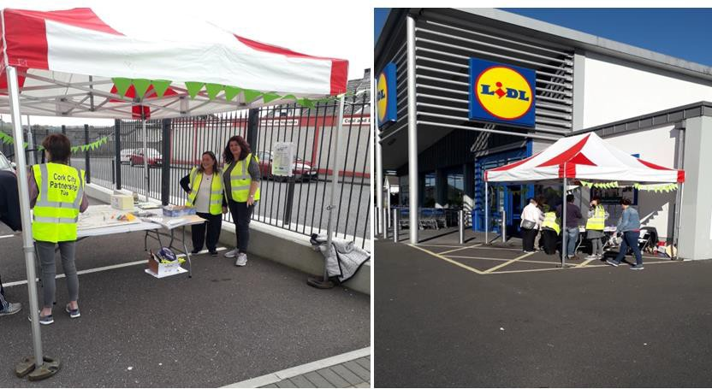

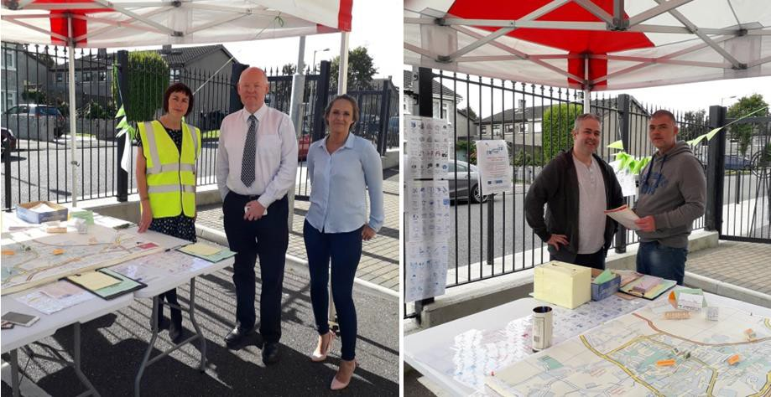
Images: Pictures from public consultation days
Banks / ATM | Of the 206 returned questionnaires – 13 responses identified the need for Bank and ATM services to be built in the area of Ballyvolane and individuals need to use areas outside of Ballyvolane especially for bank  services.
Post Office | Of the 206 returned questionnaires - 12 responses identified the need for a Post Office facility as the nearest Post Office is either  situated in Mayfield or Blackpool.
Halting Site | Of the 206 returned questionnaires - 8 responses were in connection to the Halting site- some of these responses were from the Traveller women who attended the consultation process. The issues for the Travellers were in relation to living conditions and also the nearby dump in Ellis’s Yard, other issues included the lack of housing for  Travellers in the area.
Industry | Of the 206 returned questionnaires - 4 responses related to the development of industry for the Ballyvolane which would create job opportunities for people living in the area and also for the further development of  housing in the greater Ballyvolane area.
Train / Light Rail service | Of the 206 returned questionnaires – 3 responses related to light rail and a train service being developed to alleviate the traffic  on the roads surrounding Ballyvolane plus the North ring Road and for the further

BALLYVOLANE/DUBLIN HILL AND ENVIRONS ACTION AREA PLAN

AUDIT OF SERVICES
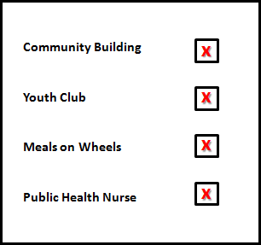
One of the less measurable narratives that came out of the public consultation exercises was the lack of services and facilities in comparison to the other areas across the north side. The vocal narrative that was relayed by both the Cork City Partnership and the Ballyvolane Community Association was the fact that because The Ballyvolane/ Dublin Hill area has been perceived a more affluent area when compared to Mayfield/the Glen and Blackpool that it has been left behind with respect to investment in social services and community infrastructure etc.
This feedback led to another level of analysis by way of an audit of services.
The full audit of services is contained in the appendix of this Area Action Plan [APPENDIX x]. A summary of the findings is as follows:
- There is no community building in the Ballyvolane/Dublin Hill area for the community to deliver services.

- Ballyvolane has the least amount of facilities/services than any of the other neighbourhoods in the north envrions

- There is a lack of youth facilities

- There is a lack of services for older persons

- Lack of leisure facilities outside of the GAA/Soccer club

- For a district centre there is a lack of retail

BALLYVOLANE/DUBLIN HILL AND ENVIRONS ACTION AREA PLAN

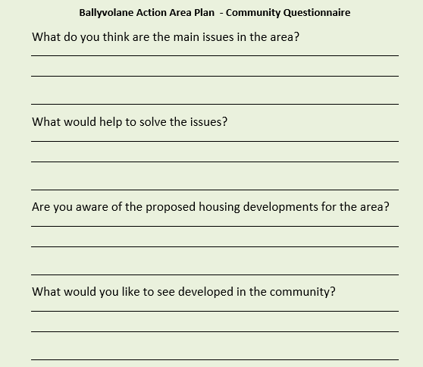

BALLYVOLANE/DUBLIN HILL AND ENVIRONS ACTION AREA PLAN

- C O N C L U S I O N S a n d I N T E R V E N T I O N S
In light of projected population and housing growth and strategic planning policy objectives, combined with the area's accessibility and proximity to the city and surrounding residential and employment districts, the Ballyvolane/Dublin Hill area represents a major opportunity for the city and for the northside in particular to embrace growth in the correct way by targeting service deficits and providing social and physical infrastructure in a pro active way.
The expanded city jurisdiction is significant. The City Council should recognize the north environs as a distinct planning area with Dublin Hill/Ballyvolane being the centre of this area serving as the economic heart and focus for investment and community services.
Following detailed analysis, and most importantly public engagement, this report has uncovered three distinct deficits in the provision of services in the area.

LACK OF A BUILDING
LACK OF SERVICES FOR OLDER PERSONS
LACK OF FACILITIES TO TAKE ACCOUNT OF THE SIGNIFICANT GROWTH IN PHYSICAL SIZE AND FUTURE POPULATIONS
Short Term Actions
As active participants and stakeholders the community and community associations need to make observations on Planning Applications to highlight the deficit and ensure that enough social and educational infrastructure is in place to cater for the new housing units proposed.
In the short term changes could be sought to proposed developments and conditions could be imposed on planning permissions to ensure that the current deficits don’t worsen as a result of an increased demand on
services. Where developments do not provide adequate services the
should be resisted.

Medium Term Actions
Coherant Planning Policy needs to be developed. Submissions during the review of the Development Plan can be made by the Community Association and Cork City Partnership appealing for community zonings and a specific Local Area Plan.
Constant dialogue with developers and Cork City Council in identifying deficits in social infrastructure – The designation of a number of community facility ‘zones’ throughout the Ballyvolane/Dublin Hill North Environs area

Loc
Location of the Dublin Hill/Ballyvolane within the wider expanded North
Environs

BALLYVOLANE/DUBLIN HILL AND ENVIRONS ACTION AREA PLAN

Longer Term Transformation
INTERVENTION NUMBER 1
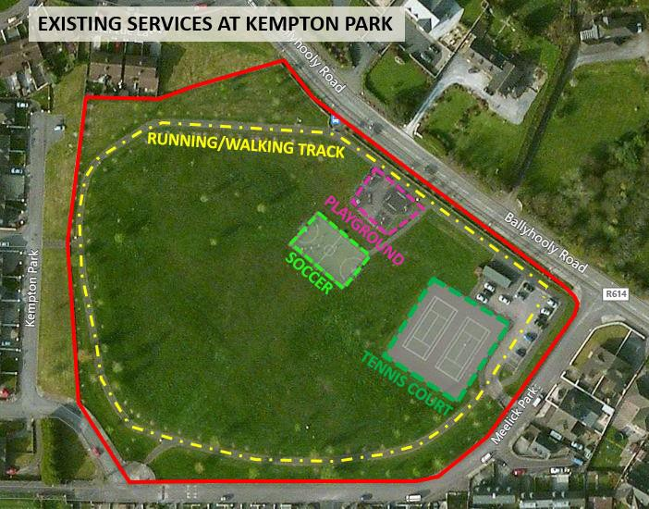
Immediate need for facilities – Kempton Park is the obvious choice as it is Council owned.

There is a clear need identified in this Area Action Plan for a building. This [taking account of the expanded area also] is most easily accommodated in the Kempton Park Community Facility.
In terms of interventions this is the primary recommendation of this Area Action Plan.
The achievement of this is a key aim of the plan and the stakeholders involved.
To achieve this there are a number of mechanisms which could be implemented:
  - The setting up of a ‘go fund me page’ with a
limit of 500,000e.
  - The making of observations [not objections] on all future planning applications for the area outlining the deficits in social infrastructure provision identified by this report and the suggestion that the relevant planning authority puts in conditions on measures to address this.
  - Lobbying of the City Council to introduce special development contributions to contribute towards the development of a community facility.

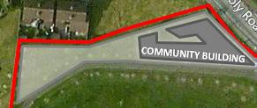
BALLYVOLANE/DUBLIN HILL AND ENVIRONS ACTION AREA PLAN

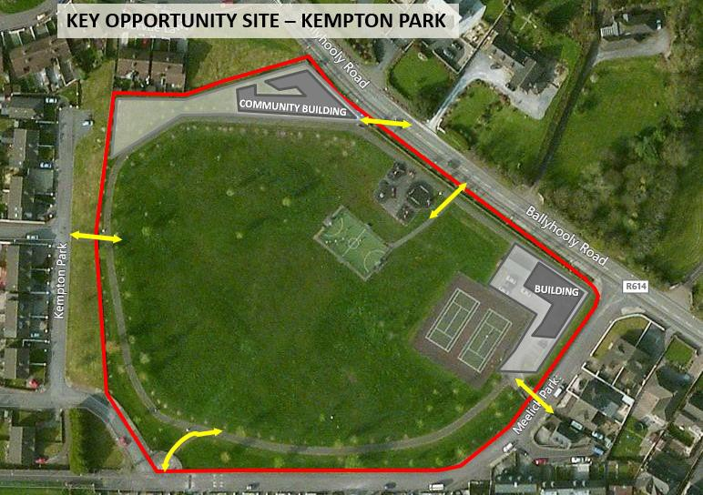
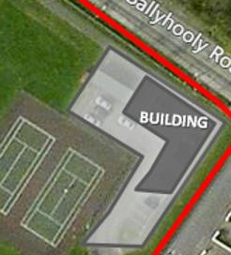
A local architect has agreed to design a suitable building and a local engineer will also donate their services. In association with the community association and wider community and the support of Butler O’Neill Total Planning Solutions a planning permission can be lodged with the consent of the Cork City Council.

BALLYVOLANE/DUBLIN HILL AND ENVIRONS ACTION AREA PLAN

There is a clear need identified in this Area Action Plan for a Local Area Plan and a community building.
This Plan represents a timely and unified vision for the future of the area and should be considered by the City Council in the development of policy objectives for the area and should also be a consideration when examining individual proposals for housing development.
It is intended that this plan would provide a focus for future action by the community, residents, local business people and the Council and act as a guidance tool for the wider community (in tandem with the City Council and other stakeholders such as developers) to implement.

BALLYVOLANE/DUBLIN HILL & ENVIRONS ACTION AREA PLAN APPENDIX : AUDIT OF SERVICES

Blackpool | Mayfield | The Glen | Ballyvolane
Available Services | Available Services | Available Services | Available Services
- Community Centre  - Blackpool Community Centre  - Adult Education & Support  - Based in Blackpool Community Centre  - Health Action Zone | - Community Centre  - St. Joseph’s  Community Centre,  - Kerrigan Tyrell Community Centre,  - Newbury House  - Mayfield Integrated Community Development Project  - Ard Bhaile Community Centre  - Lotamore Family Resource Centre  - Adult Education and Support  - Mayfield  Community Adult Learning Project (CALP)  - Mayfield Write-On  - Health Action Zone | - Community Centre  - Glen Resource & Sports Centre  - Carnloch  Community Building  - St. Brendan’s Day Centre (older people)  - Adult Education and Support  - ABLES The Glen  - The Dillon’s  Cross Project  - Cork City  Partnership Community Education  - Health Action Zone | - Glenfield Community room

BALLYVOLANE/DUBLIN HILL & ENVIRONS ACTION AREA PLAN APPENDIX : AUDIT OF SERVICES
- Cork City Partnership Offices x 2  - Library  - Health Care Centre  - Public Health Nurse  - Medical Centre x 4  - South Doc  - Dental Clinic/ surgery  - Opticians  - Health Care Centre  - Part of Blackpool Community Centre  - Credit Union  - Garda Station  - Post Office  - Blackpool Shopping Centre  - Blackpool Retail Park  - Cork Community Art Link  - Cork Counselling Services  - North Lee Social Work Dept  - Chiropractor  - Moldavian Super Market  - Polish Super Market  - Church  o Annunciation  - Chemist x 4  - Schools (Within the Blackpool district) | - Cork City Partnership  - Library  - Health Care Centre  - Public Health Nurse  - Dr. Surgery  - Dental Clinic/ surgery  - Credit Union  - Garda Station  - Post Office  - Shopping Centre  - Church  - St. Joseph’s  - Our Lady Crown  - Chemist  - Schools  o Mayfield Community Pre- | - Cork City Partnership  - Public Health Nurse  - Based in Glen Resource Centre)  - Church  - St. Brendan’s  - Schools  - St. Mark’s Boys | - Public Health Nurse Office (part of Glenfield Crèche)  - Dr. Surgery  - Dental Clinic/ surgery  - Shopping Centre  - Fire Station  - Church  - St. Oliver’s  - Chemist  - Schools  - St. Aidan’s

BALLYVOLANE/DUBLIN HILL & ENVIRONS ACTION AREA PLAN APPENDIX : AUDIT OF SERVICES
- Blackpool / Glen/Farranree Community Training Centre  - North Monastery Primary,  - North Mon Secondary  - North Mon A G  - Gael Scoil Peg Sayer Primary  Boys & Girls  - St. Vincent’s Primary  - St. Vincent’s Secondary School  - Pre School  - St Vincent’s Pre School  - Farranferris Pre- School  - Muin Preschool (Private pre- school)  - Sporting Facilities / Clubs  - Astro Turf 5 a side Blackpool  Community Centre | school  - Mayfield Community School  - Naomh Eoin Easpal& Scoil Mhuire Banrion Boys & Girls Primary  - Gael Scoil Ghoirt Álainn  - St. Killian’s  - Mayfield Community Training Centre  - Cara Junior School  - Pre School  - Roseville house Pre School  - Mayfield  Community Preschool  - Angel Guardian Community Pre School  - Crèche  - Baile Beag Community Childcare, Árd Bhaile Community Centre  - Rainbow Childcare  - Newbury Preschool and Crèche  - Sporting Facilities/ Clubs  - Mayfield Leisure Centre  - Mayfield GAA | primary  - St. Brendan’s  Girls Primary  - Glen Youthreach  - Pre School  - Na Paisti Beag & Mor  - Glentrasna Community Pre School  - Crèche  - Tir na nÓg, Glen Resource Centre  - Sporting Facilities/ Clubs  - Glen Resource &  Sports Centre | Community College Secondary School  o St. Oilibheir’s Boys & Girls Primary School  - Pre School  - Glenfields  - Crèche  - Glenfields Community Childcare,  - Sporting  Facilities/Clubs  o Glen Rovers GAA

BALLYVOLANE/DUBLIN HILL & ENVIRONS ACTION AREA PLAN APPENDIX : AUDIT OF SERVICES
- Blackpool Celtic FC  - Sitjaipetch Muay Thai Club  - Youth Facilities  - Blackpool Youth Club  - Cork Foyer /Garden Café  - Foroige Head Office  - Youth Advocate Programme  - Play Ground  - Assumption Hill Play Ground  - Foyer play area  - Blackpool Shopping Centre Amenity Park  - Bank  - Bank of Ireland  - Permanent TSB  - ATM  - Public Transport  o 203/215/201/207A | - Mayfield Soccer Club  - Astro Turf  - Brian Dillon’s Hurling &  Football Club  - Iona Bowls Club  - Mayfield Renshukan Karate Club  - Youth Facilities  - No Name Club  - St. Joseph’s Youth  Affairs  - Mayfield  Neighbourhood Youth Project  - Youth Café  - Mayfield Brass band  - Play Ground  - Glenamoy Lawn Park  - ATM  - Public Transport  o 208/201 | Astro Turf 5 a side  - Glen Bowls Club  - Glen Celtic Football Club (Glen Park Playing pitch)  - Youth Facilities  - Glen NYP  - Glen Garda Youth Diversion Project  - Glen Youth Development Project  - Glen Young Adults Project  - Play Ground  - Glen Amenity Park  - Public Transport  - 207A/248 | ( Pitches)  - Delaney’s GAA (Pitches)  - Leeds FC Soccer Club (Pitches)  - Glenthorn FC Soccer Club (Pitch)  - Youth Facilities  - Drugs Task Force Worker working with young Adults  - Play Ground  - Kempton Park  - ATM  - Public Transport  o 207  o 201

BALLYVOLANE/DUBLIN HILL & ENVIRONS ACTION AREA PLAN 2019


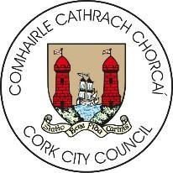


The Social Inclusion and Community Activation Programme (SICAP) 2018-2022 is funded by the Irish Government through the Department of Rural and Community Development and co-funded by the European Social Fund under the Programme for Employability, Inclusion and Learning (PEIL) 2014-2020.

