Ballincollig Multipurpose Community Centre
Project

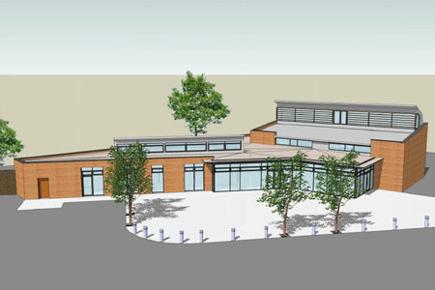

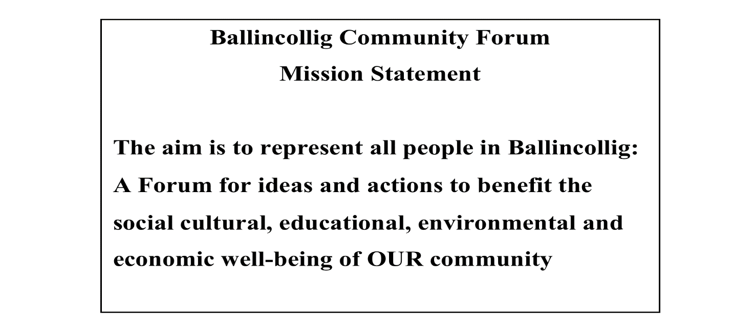

What is the Ballincollig Community Forum?
- The BCF was officially formed in 2010 following a number of well attended public meetings,
- It is a Forum for ideas and actions to benefit the, social, cultural, environmental and economic well-being of the community.
- The aim of the Forum is to represent all the people in Ballincollig.
- Ballincollig is very lucky in that it has some of the strongest, most successful clubs and groups in the County
- But it is no co-incidence that Ballincollig is also one of the largest population centres in Ireland, never mind Cork
- But unfortunately, for a number of reasons has never had a central organisation to help pull all the expertise, knowledge and experience together for the benefit of the community.
- The Community Forum is hoping, with the help of the organisations and the people of Ballincollig, to do just that.

Summary of Needs analysis
- In 1998, the Society of Saint Vincent de Paul in Ballincollig completed an analysis of the needs and requirements of the people living in the area.
- In 1999, following the closure of the Murphy Army Barracks, and the commitment of the Minister for Defense to allocate 10% of the Army Lands for community use, a second comprehensive needs analysis was conducted by over 21 organisations in the social and voluntary sector in Ballincollig.
- In 2005, Clarity Research Development and Training Ltd (Clarity RDT) also conducted a needs analysis, particularly with regard for the need for a multi-purpose youth hall in Ballincollig.
- In 2009, Ballincollig Community Forum held a public community meeting to assess the needs of the people living in Ballincollig. A total of over 160 people attended with representatives from over 20 clubs and organisations attending.
- Ballincollig Community Forum is currently in discussions with the clubs and organisations within Ballincollig to assess whether the needs of the town have changed within the last 5 years.

Ballincollig of 2018 is a very vibrant town with plenty of shopping facilities, schools, and voluntary and community organisations. The town has a designated facility (Westgate Foundation) to cater for the older population and it has very many sporting clubs that cater to young and old alike. However, despite the development of Ballincollig over the last 17 years, a population increase of approximately 30% and a current catchment population of 28,256, the primary needs of the community as identified in the afore-mentioned needs analyses have remained consistent. The lack of development of community facilities in Ballincollig has ensured that each needs analysis undertaken has identified a dearth of facilities in the following areas:
- Youth
- Sports and Recreation
- Community Space
- Arts and Heritage

Youth Facilities
The youth population in Ballincollig has increased by 25.1 % in the last 10 years and currently stands at 34.3% of the overall population (C.S.O, 2018) is under the age of 25. The town has four primary schools: two co-educational, Scoil Barra and Gaelscoil Ui Riordain; one boys school, Scoil Eoin and a girls’ school, Scoil Mhuire. It also has two secondary schools: Colaiste Choilm which has a Gaelscoil adjacent to its building and Ballincollig Community School. Both secondary schools cater for more than 2000 students between them. The town also has a special needs school, Our Lady of Good Counsel, that caters for approx 60 children from all over Cork.
It is generally accepted that the needs of the youth population in Ballincollig are diverse and are the most critical needs that must be addressed. There are some structured organizations catering for young people in the town that meet some of these needs. Ballincollig is home to the 49th Scout Troop, founded in 1972 and has a membership of over 150 youth and 20 adult members, ranging in age from six to sixty. Ballincollig also has a very strong Girl Guide group which is in existence for over 40 years, catering for young girls between the ages of six and eighteen and has over 160 youth members. There are also targeted youth groups within Ballincollig, including Ballincollig Action Project, YMCA, PACT and SVDP, to name a few, that provide a service for our young people. However as these groups are targeted, there is criteria attached to membership and spaces are limited
Ballincollig has only one dedicated youth club (Club na hOige) that caters for all ages. It is very active in the community and provides a space and activities for its members. Club na hOige currently has a waiting list of young people that are anxious to use its services. The youth club rents space from Saint Vincent de Paul, however the space is inadequate for the amount of young people in Ballincollig and currently can only cater for 45 young people at a time. This club is managed by a large dedicated group of volunteers that are willing to put the time into facilitating the young people of Ballincollig. More physical space is needed to facilitate the youth population and implement activities that would benefit them socially, emotionally and developmentally.

It is accepted that youth use of adult space does not always work well whereas the reverse is not as much of an issue. Therefore, considering the demographic make-up of Ballincollig, with over 34% of the population under 25, the lack of a dedicated youth space is a major concern for the community of Ballincollig. It is clear that the development of a suitable youth service for a town the size of Ballincollig with such a large youth population is essential. The needs of the youth require to be responded to on a physical, social and developmental level. An integrated approach in a dedicated youth space by the various groups in Ballincollig that currently cater for young people is essential in providing an appropriate level of service.

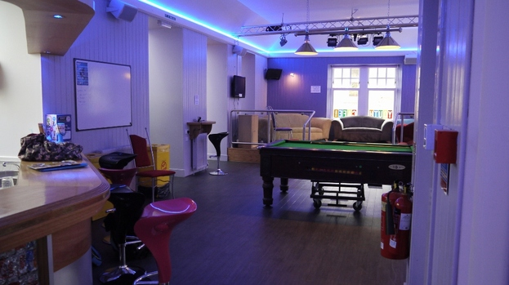
Breakdown of demographics by Age Category.
Age Group | Male | Female | Total
0 | 121 | 117 | 238
1 | 173 | 148 | 321
2 | 149 | 131 | 280
3 | 173 | 125 | 298
4 | 152 | 144 | 296
5 | 180 | 153 | 333
6 | 152 | 149 | 301
7 | 149 | 149 | 298
8 | 157 | 155 | 312
9 | 116 | 119 | 235
10 | 133 | 128 | 261
11 | 125 | 131 | 256
12 | 123 | 128 | 251
13 | 149 | 123 | 272
14 | 126 | 110 | 236
15 | 110 | 98 | 208
16 | 142 | 109 | 251
17 | 125 | 109 | 234
18 | 121 | 116 | 237
19 | 124 | 128 | 252
20-24 | 543 | 477 | 1,020
Cso.ie (Census statistics 201
Sports Facilities
Ballincollig prides itself locally and nationally for their dedication and achievements in the sporting area. It is home to many different sporting clubs and associations ranging from soccer to Frisbee. There are sports facilities available privately for rent in Ballincollig, however the GAA club and the Rugby club are the only sport clubs that own their own building and sports facilities. Ballincollig soccer club recently acquired its own pitches but do not have a club house.

Over the past few years, many of the sporting organisations in Ballincollig have experienced significant increases in membership. In the absence of additional facilities, many of the organisations have been forced to restrict their level of services and/or membership.
Current clubs in Ballincollig that are renting private space for their training needs include but are not limited to the: Basketball Club; Tennis Table Club; Soccer Club; Camoige Club; Athletics Club and Hockey Club.

The development and expansion of these clubs is reliant on the availability of a space that they can have ownership of and can use to meet the needs of the community and fulfil their sporting ambitions. A dedicated sports centre is needed to meet the needs of existing clubs, promote their development and expand their membership while allowing new clubs to establish.

Community Space
Ballincollig currently has two community spaces. A community centre located on Station Road is over 30 years old and can no longer accommodate the demand from the population and organisational demand for community space. Due to its location, expansion of the premises is not possible. Ballincollig Family Resource Centre located in the Village Shopping Centre is very active in providing services for the community, particularly those experiencing disadvantage. It also provides space for community organisations to hold their meetings. However again space is limited and the focus on disadvantage, limits the use available to the community. Neither of these community facilities has the space needed to meet the needs of the community.
There are many dedicated community and voluntary organisations in Ballincollig; very few of whom have premises to call their own. Many organisations hold their committee meetings in a hotel lobby; an upstairs room in a pub; the kitchen of a community house and many more inadequate spaces. Despite the inadequate facilities available to them, these organisations are very accomplished and provide much needed services for the community. There is a clear need to facilitate these organisations and ensure that they have adequate space to work out of and continue to grow and develop. An added benefit of bringing all of these community and voluntary organisations under a common roof is the potential for the sharing of expertise and resources and the increased capacity building of the whole community.

Arts Culture and Heritage
Ballincollig is a hub for arts, culture and heritage; most famously the Gunpowder Mills and all that comes with that. A community centre is needed to allow us as a community to showcase our heritage and promote our town to visitors as well as residents that may not be aware of the historical aspect of the town.
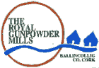
Heritage
Ballincollig is a very former military town with the remains of the barracks as well as the historic gun powder mill. As such it has many historical artefacts that relate to this time. Unfortunately there is no space to display these artefacts in Ballincollig. They are currently being stored in Spike Island and are not accessible to the public. The importance of displaying these artefacts in Ballincollig can not be emphasised enough. Our heritage needs to be acknowledged and celebrated. The development of a multi-purpose community centre in Ballincollig will provide a space to display these artefacts and ensure that the history of Ballincollig is not relegated to the pages of a history book. Such a facility would also help to promote tourism in the town and help boost the local economy.

Culture
Ballincollig is a multi-national town and there is a strong need for a community space that offers an integrated approach to bringing all the people of Ballincollig together. While all of the schools are integrated and the youth of Ballincollig have many opportunities to mix with the various cultures and nationalities represented, there is no such facilities for the parents of these children or people who moved here as adults. Many adults continue to struggle with the English language as they do not have the opportunity to mix with on a social basis with the rest of the community. A multi-purpose centre is needed to provide an opportunity for all members of the community to avail of the services and facilities that it will entail. Having ownership of the centre will increase the sense of belonging for every resident in Ballincollig and will help to strengthen Ballincollig as an intercultural and integrated town.

Art
There are a number of both art and drama groups active in Ballincollig. However necessary purpose built facilities for these activities are non-existent in the town. Art classes are held in community houses, in the Family Resource Centre and in the GAA hall, none of which have adequate equipment, light or fixtures, limiting the capacity for progression. Space provided is small ensuring available places are limited. A dedicated art room with the correct fixtures and fittings is needed to allow art groups in Ballincollig to develop, progress in their artistic endeavours and expand their membership. It would also allow other groups to attempt new skills or become involved in community art projects, such as the St. Patricks Day Parade etc.

The drama, dance and music groups in Ballincollig are faced with the same dilemma. There are a number of theatre groups currently active in the Ballincollig area, however they are all based on adult membership as the space is not there to facilitate younger members. Rehearsals take place in the current community centre. This takes place upstairs (with no disability access). The space is limited and facilities are not adequate. Other rehearsal take place in members’ home and ad hoc meeting rooms. As noted earlier, the needs of young people are diverse and there is a gap in arts and drama services provided for them in the town. There is a need to provide a rehearsal hall and a public performance area to address these needs and nurture and develop diversity in activity. We need to ensure that the young people of Ballincollig are not restricted to sporting activities, rather that they have the opportunity to experience the music, drama and the arts in an environment that is purpose built to meet their needs.

Conclusion
The development of Ballincollig as a town over the last number of years has exceeded all expectations. It is a vibrant town with wonderful facilities to meet many of the needs of the population. However, the lack of development of community facilities in the town has restricted the growth and development of individuals, clubs and organisations alike.
- There is a severe dearth of facilities for the youth of the town.
- There are limited sport and recreational facilities
- There are no adequate facilities to promote arts and drama in the town
- There is no facility to showcase our heritage and promote Ballincollig as a tourist area
The absence of identifiable community life encourages isolation and a lack of community responsibility which in turn encourages further isolation and in increase of the issues and needs among the population.

The implementation of proper social facilities ensures that people have a place to come together, work together and identify with one another. The development of a coherent and cohesive plan for the social community of Ballincollig is essential for the growth and development of Ballincollig as a sustainable town with a self-sufficient population.
Community centres have a historical role in the social enhancement of a town. A well planned and community built centre can:
- Develop into the social heart of the town
- Develop a strong sense of identity among community members
- Promote community spirit and develop a sense of self-sufficiency
- Provide a comprehensive range of sports, recreational, leisure, arts, drama, music and cultural programmes
- Bring all the clubs and organisations in the town under one physical roof, thereby facilitating the sharing of information and resources, resulting in community capacity building.

“One of the marvelous things about community is that it enables us to welcome and help people in a way we couldn't as individuals. When we pool our strength and share the work and responsibility, we can welcome many people, even those in deep distress, and perhaps help them find self-confidence and inner healing.”
Jean Vanier, Community And Growth
Description of proposed multi-purpose community centre
As outlined in the needs analysis above, the proposed multi-purpose community centre will focus on the following four key areas:
- Youth
- Sports and Recreation
- Community Space
- Arts, Heritage and Culture

Building Type | Relative Area | Target Users
Sports Hall  Youth Centre  Community Space  and  Arts and Heritage | 990 sq m  225 sq m  532 sq m | Local and Regional Sports Clubs  Disabled Sports Clubs  Private Sports Groups  Community Groups  Local Schools  Private Individuals – Climbing Wall  Local Youth Club  Targeted Youth Groups  Local Community Groups  Schools  Art Groups  Local Community Groups  Heritage/ Historical Societies  Community Members  Educational / Training Groups  Local and Regional Theatre Groups  Local and Regional Musicians and Dancers

Youth Facilities
The dedicated youth space will be a social and recreational centre intended primarily for use by children ages 7 to 18 years. In some cases, children as young as six years old will use the Youth Centre, but usually only if special programmes are in place to accommodate them. The Centre will support opportunities for youth to develop their physical, social, emotional, and cognitive abilities and to experience achievement, leadership, enjoyment, friendship, and recognition.

The Youth Centre will offer organised instructional programmes for physical activities such as dance, yoga, and martial arts and for academic and arts programmes such as science, crafts, and theatre. It will also offer opportunities for unstructured activities such as game playing, socializing, club meetings, and outdoor play.

The youth centre will consist of:
- A common area that can facilitate a youth café; youth clubs and other youth targeted groups that are currently operating in the area.
- An art room that will facilitate youth art groups.
- A coffee dock
- An I.T. room
- A Stage area and Blue Room
- A Multi-Purpose Room

ART ROOM
Common Room
Coffee Dock

I.T Room
Blue Room
Multi Purpose Room

Stage

While these areas will be dedicated youth spaces, they will also be made available to adults to ensure maximum use of the rooms.

Sports and Recreation
The sports and recreation hall will be 690sq metres. These dimensions allow for a range of sports at various levels of play:
Basketball: Club/Community/Training
Badminton: Club
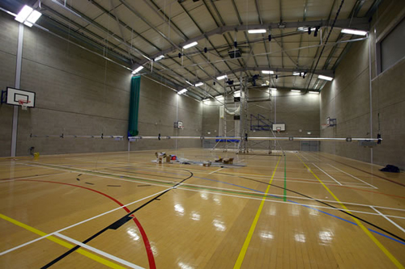
Gymnastics: Training
Five-a-side Soccer: Club
Futsal: Club
Handball: Community
Netball: Community
Volley Ball: Premier/ Training
Table Tennis: National/ Training
Camoige: Training
Martial Arts: Tournaments/ Displays/ Training
Boxing: Tournaments / Training
A 1500 turning circle will be maintained throughout the sports centre to facilitate disabled sports.

Each sports group in Ballincollig in need of facilities to meet the needs of their membership is currently and will continue to be engaged in comprehensive consultation to ensure that the sports hall is of a size, structure and nature to meet their needs. The sports hall will have a divider in place to facilitate smaller group and ensure the efficient running of the hall.
There will be changing rooms, shower areas and bathrooms attached to the sports hall. There will also be storage facilities to meet the needs of community sports groups. There will be retractable seating to facilitate viewers and a balcony viewing area.
While the primary aim of the sports hall is to meet the needs of community groups, it is envisioned that this hall will also serve many people outside of Ballincollig and generate income from the facilitation of sports tournaments, disability sports, sports displays and private classes. One of the walls in the sports hall will also consist of a climbing wall which will help to generate income.

Blue Room

Stage area

Sports Hall
W/C
Changing
Facilities

Shower Facilities

Storage

Community Space
The proposed community facility will be a Centre point for the people of Ballincollig. It is envisioned that it will become the heart and cultural centre of the town. The community has been, and will continue to be, involved in the development of the centre. It is important that the community have ownership over the centre and have a sense of belonging both to the centre and the community itself. It is also important to provide a space that can serve many different functions according to individual and group needs/wants.

The foyer will be an open, welcoming space. It will encompass a reception area, a soft seating open meeting area, an information area, a display area and a walk through to the coffee dock. The foyer will be a central part of the facility that will be available to the community as a drop-in centre for people just to meet up, have a cup of coffee and find out what is happening in town. It will also provide a space for the community to recognise, acknowledge and be proud of what every group in the community has achieved.
There will be 5 community meeting rooms in the centre: 3 that can facilitate up to 20 people; 1 that can facilitate 25; 2 that can facilitate 30 people. Two of these meeting rooms will have a dividing wall between them which can be opened up to facilitate a group of up to 55 people. One of these rooms will also have one-way glass to facilitate HSE or prison services in the future. (Supervised family visits etc). There will also be I.T room that can facilitate up to 20 people.
While each of the rooms in the centre will be multi-purpose and available to a wide range of people and groups, each of the voluntary/community groups operating in Ballincollig will have a dedicated space which they can use for administrative duties. They will have a lockable filing cabinet and access to equipment needed to help their organisation to develop and progress. This type of permanent residence for groups will also provide a space for groups/ organisations in Ballincollig to work side by side while building their capacity to work together and share information and resources.
One of the rooms will be dedicated to facilitating people searching for employment. Links have been built with Ballincollig Business Association and SECAD and are currently been built with the local community welfare officers. A current and regularly updated information board advertising employment opportunities will be a permanent feature of this room. Daily newspapers will be provided, templates for updating C.V.s and other facilities including I.T. facilities will also be provided.

M.P Room 2
M.P Room 3
M.P Room 1
Information Area
Coffee Dock

Reception/Foyer
Soft Seating
Area

Viewing Area
M.P Room 4

M.P Room 5

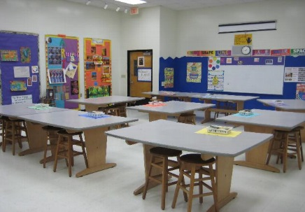
Arts, Heritage and Culture
This community centre will be dedicated to enhancing, promoting and developing the arts, heritage and culture within Ballincollig.
There will be a dedicated art room that any community group in Ballincollig can access for a nominal fee. It is envisioned that this will be an inspirational meeting room for planning and implementing Community Events such as the St. Patricks Day Parade etc. This room will also be available to rent to private art groups to generate income.

Within the sports centre there will be a retractable stage and a large back stage area. This will be available to local drama societies, local schools and other community groups with an interest in developing their acting abilities. There will be a sound-proofed ‘blue room’ for sound equipment and recording as well as changing rooms to facilitate costume changes. The stage and accompanying hall will also be available for small concerts and music festivals. The blue room will be made available to community members, particularly the youth, to facilitate the development of their music. The sports hall would also be a potential venue for ‘Battle of the Bands’ and other such competitions.

One of the main attractions of the foyer will be a display of Ballincollig’s heritage in the form of the artefacts currently being stored in Spike Island. In conjunction with Ballincollig Heritage/ Historical society, a number of display cases will be designed to ensure that our heritage is acknowledged and celebrated. This will be a featured attraction of the centre and has the potential to develop into a mini museum and cultural hub.

Blue Room

Stage Area

Foyer

Display Area

Art Room

Sports Hall

Proposed Build

Room | Client Areas  Square Metres | Likely Areas  Square Metres
Sports Hall | 690 | 690
Changing Rooms x 2 | 64 | 64
Shower Area x2 | 32 | 32
Storage | 37.5 | 37.5
Upstairs Unisex Disabled Toilet | 3.3 | 7.0
Downstairs Unisex Disabled Toilet | 6.6 | 7.0
Toilets x2 | 60 | 60
Back Stage area | 100 | 100
Reception | 14 | 14
Foyer | 92 | 92
Meeting room 1 (30 people) | 39 | 45
Meeting room 2 (25 people) | 34 | 34
Meeting room 3 (20 people) | 30 | 30
Meeting room 4 (20 people) | 30 | 30
Meeting room 5 (30 people) | 39 | 45
Youth Café | 95 | 95
Art Room | 46.5 | 46.5
Blue Room | 28 | 28
Coffee Dock | 30 | 30
Office 1 | 20 | 20
Office 2 | 20 | 20
Office 3 | 28 | 20
Office 4 | 28 | 20
I.T Room (20 people) | 65 | 80
Staff Room | 30 | 30
Storage Rooms x 2 | 40 | 40
Hallways/Corridors/ Lifts/Stairs | 159.4 | 159.4
Contingency say 10% (Design Not Finished) | 186.13 | 187.64
Total | 2047.43 | 2064.04

A 1500 turning circle will be maintained throughout the Community centre to facilitate disabled members.

Funding Strategy
The total cost of this multipurpose community centre stands at €4,383,566.25

